A PROJECT REPORT ON

## SMART LOAD BALANCING FOR ENHANCED CLOUD COMPUTING PERFORMANCE IN DATA CENTERS

Submitted By

**U. PALLAVI 21JD1A05B6**

**SK. AMEERULLA 21JD1A05C7**

**S. SOWMYA 22JD5A0511**

**U. DURGA PRASAD 21JD1A05D0**

***in partial fulfillment of the requirements for the award of the degree of***

## BACHELOR OF TECHNOLOGY

**In**

## COMPUTER SCIENCE & ENGINEERING

##### Under the Esteemed guidance of Mr. D. LOKESH M.C.A., (M.Tech)

##### Assistant Professor



## DEPARTMENT OF COMPUTER SCIENCE & ENGINEERING ELURU COLLEGE OF ENGINEERING AND TECHNOLOGY

**DUGGIRALA (V), PEDAVEGI (M), ELURU-534004**

**(AFFLICATED TO JNTUK, KAKINADA, ANDHRA PRADESH (INDIA)) 2021-2025**

# DECLARATION

We here by declaring that the project entitled **“SMART LOAD BALANCING FOR ENHANCED CLOUD COMPUTING PERFORMANCE IN DATA CENTERS”** Submitted for the B.Tech. (CSE) degree is our original work and the project has not formed the basis for the award of any other degree, diploma, fellowship or any other similar titles.

**U. PALLAVI (21JD1A05B6)**

**SK. AMEERULLA (21JD1A05C7)**

**S. SOWMYA (22JD5A0511)**

**U. DURGA PRASAD (21JD1A05D0)**

**Place: Date:**

# CERTIFICATE

This is to certify that the Project titled “**SMART LOAD BALANCING FOR ENHANCED CLOUD COMPUTING PERFORMANCE IN DATA CENTERS**” is the bonafide work carried out by **U.PALLAVI (21JD1A05B6), SK.AMEERULLA (21JD1A05C7), S.SOWMYA (22JD5A0511), U.DURGAPRASAD (21JD1A05D0)** students of B.Tech (CSE) of Eluru College of Engineering and Technology, affiliated to JNT University, Kakinada, AP (India) during the academic year 2024-25, in partial fulfillment of the requirements for the award of the degree of Bachelor of Technology (Computer Science and Engineering) and that the project has not formed the basis for the award previously of any other degree, diploma, fellowship or any other similar title.

##### Signature of the Guide Signature of the HOD

**Mr. D. LOKESH**, M.C.A.,(M. Tech) **Dr. S. SURESH** , B. Tech. , M. Tech., Ph.D

**Assistant Professor Professor**

**EXTERNAL EXAMINER**

**VISION – MISSION - PEOs**

|  |  |
| --- | --- |
| **Institute Vision** | To Achieve Excellence in Engineering Education |
| **Institute Mission** | IM1: To deliver quality education through good infrastructure, facilities and committed staff.  IM2: To train students as proficient, competent and socially responsible engineers.  IM3: To promote research and development activities among faculty and students for betterment of the society. |
| **Department Vision** | Empower the students of computer science and engineering  department to be technologically strong, innovative and global citizens maintaining human values. |
| **Department Mission** | DM 1: Inspire students to become self-motivated and problem solving individuals.  DM 2: Furnish students for professional career with academic excellence and leadership skills.  DM 3: Create centre of excellence in Computer Science and Engineering.  DM 4: Empower the youth and rural communities with computer education. |
| **Program Educational Objectives (PEOs)** | Graduates of Computer Science & Engineering will:  PEO1: Excel in Professional career through knowledge in mathematics and engineering principles.  PEO2: Able to pursue higher education and research.  PEO3: Communicate effectively, recognize, and incorporate societal needs in their professional endeavors.  PEO4: Adapt to technological advancements by continuous learning. |

## PROGRAM OUTCOMES

|  |  |
| --- | --- |
| **1** | **Engineering Knowledge:** Apply the knowledge of mathematics, science, engineering fundamentals and an engineering specialization to the solution of complex engineering problems. |
| **2** | **Problem analysis**: Identify, formulate, review research literature, and analyze complex engineering problems reaching substantiated conclusions using first principles of mathematics, natural sciences, and engineering sciences. |
| **3** | **Design/development of solutions**: Design solutions for complex engineering problems and design system components or processes that meet the specified needs with appropriate consideration for the public health and safety, and the cultural, societal, and environmental considerations |
| **4** | **Conduct investigations of complex problems**: Use research-based knowledge and research methods including design of experiments, analysis and interpretation of data, and synthesis of the information to provide valid conclusions. |
| **5** | **Modern tool usage**: Create, select, and apply appropriate techniques, resources, and modern engineering and IT tools including prediction and modeling to complex engineering activities with an understanding of the limitations. |
| **6** | **The engineer and society**: Apply reasoning informed by the contextual knowledge to assess societal, health, safety, legal and cultural issues and the consequent responsibilities relevant to the professional engineering practice. |
| **7** | **Environment and sustainability**: Understand the impact of the professional engineering solutions in societal and environmental contexts, and demonstrate the knowledge of, and need for sustainable development. |
| **8** | **Ethics**: Apply ethical principles and commit to professional ethics and responsibilities and norms of the engineering practice. |
| **9** | **Individual and team work**: Function effectively as an individual, and as a member or leader in diverse teams, and in multidisciplinary settings. |
| **10** | **Communication**: Communicate effectively on complex engineering activities with the engineering community and with society at large, such as, being able to comprehend and write effective reports and design documentation, make effective presentations, and give and receive clear instructions. |
| **11** | **Project management and finance**: Demonstrate knowledge and understanding of the engineering and management principles and apply these to one’s own work,  as a member and leader in a team, to manage projects and in multidisciplinary environments. |
| **12** | **Life-long learning**: Recognize the need for, and have the preparation and ability to engage in independent and life-long learning in the broadest context of  technological change. |

**PROGRAM SPECIFIC OUTCOMES**

**PSO1:** Have proficiency in algorithms, networking, s/w Engineering and Web Applications for systematic design of computer based system of varying complexity. **PSO2:** Qualifying national, international level competitive examinations for successful higher studies and employment.

## PROJECT MAPPINGS

|  |  |
| --- | --- |
| **Batch No:** | B - 9 |
| **Project Title** | Smart Load Balancing For Enhanced Cloud Computing Performance In Data Centers |
| **Project Domain** | Cloud Computing |
| **Type of the Project** | Application – oriented |
| **Guide Name** | D. Lokesh, M.C.A., (M. Tech) |
| **Student Roll No** | **Student Name** |
| **21JD1A05B6** | U. Pallavi |
| **21JD1A05C7** | SK. Ameerulla |
| **22JD5A0511** | S. Sowmya |
| **21JD1A05D0** | U. Durga Prasad |

**COURSE OUTCOMES:** At the end of the Course/Subject, the students will be able to

|  |  |  |  |  |
| --- | --- | --- | --- | --- |
| CO.No | Course Outcomes (COs) | POs | PSOs | Blooms Taxonomy &  Level |
| R20C501.1 | Identify the real world problem with a set of requirements to design a  solution. | 1,2,3,4,5,6,9,10,11,12 | 1,2 | Level-2: Applying |
| R20C501.2 | Implement, Test and Validate the solution against the requirements  for a given problem. | 1,2,3,4,5,7,8,9,10,11,12 | 1,2 | Level-3: Analysing |
| R20C501.3 | Lead a team as a responsible member in developing software solutions for real world problems and societal  issues with ethics. | 1,3,4,5,6,7,8,9,10,12 | 1,2 | Level-4: Analysing |
| R20C501.4 | Participate in discussions to bring technical and behavioral ideas for good  solutions. | 1,2,3,4,5,6,7,8,9,10,11,  12 | 1,2 | Level-5: Evaluating |
| R20C501.5 | Express ideas with good communication skills  during presentations. | 1,5,6,7,8,9,10,12 | 1,2 | Level-1: Creating |
| R20C501.6 | Learn new technologies to contribute in the software industry for  optimal solutions. | 1,2,3,4,5,7,8,9,10,11,12 | 1,2 | Level-6: Creating |

**Course Outcomes vs PO`s Mapping:**

|  |  |  |  |  |  |  |  |  |  |  |  |  |
| --- | --- | --- | --- | --- | --- | --- | --- | --- | --- | --- | --- | --- |
| Courses Out Comes | P01 | P02 | P03 | P04 | P05 | P06 | P07 | P08 | P09 | P10 | P011 | P012 |
| R20C501.1 | 3 | 3 | 3 | 2 | 3 | 3 | - | 3 | 3 | 3 | 3 | 3 |
| R20C501.2 | 3 | 3 | 3 | 3 | 3 | - | 3 | 3 | 3 | 3 | 3 | 3 |
| R20C501.3 | 2 | - | 3 | 3 | 3 | 3 | 3 | 3 | 3 | 3 | 3 | 3 |
| R20C501.4 | 3 | 3 | 3 | 3 | 2 | 3 | 3 | 3 | 3 | 3 | 3 | 3 |
| R20C501.5 | 3 | - | - | - | 3 | 3 | 3 | 3 | 3 | 3 | 3 | 3 |
| R20C501.6 | 2 | 3 | 3 | 3 | 3 | - | 3 | 3 | 3 | 3 | 3 | 3 |
| Total | 16 | 12 | 15 | 14 | 17 | 12 | 15 | 18 | 18 | 18 | 18 | 18 |
| Average | 2.6 | 2 | 2.6 | 2.3 | 2.8 | 2 | 3 | 3 | 3 | 3 | 3 | 3 |

**Justification of Mapping of Course Outcomes with Program Outcomes: POs mapped with CO.No:R20C501.1:**

**PO-1: Engineering Knowledge:**

Applying the various concepts learned from engineering to gather requirements**. PO-2: Problem Analysis:**

Identify the formulae and obtaining the layout of the design using mathematical principles.

##### PO-3: Design/Development of solutions:

Identifying and Designing solutions for the problems related to health, cultural, society and environmental considerations.

##### PO-4: Conduct investigation of complex problems:

Researching various journals and published papers and knowing how to solve complex problems.

##### PO-5: Modern Tool Usage:

Selecting and Implementing the latest versions of the applications for modelling the complexity of the project.

##### PO-6: The Engineer and Society:

Implementing this knowledge to assess health and safety considerations.

##### PO-8: Ethics:

Implementing professional ethics and norms in engineering practices.

##### PO-9: Individual and Teamwork:

Individuals researched on the interested domain and concluded the requirements as a team.

##### PO-10: Communication:

Communication is needed to identify the problem and work as a team to define a solution.

##### PO-11: Project Management and Finance:

Implementing the engineering principles to work on complex problems.

##### PO-12: Life-long Learning:

Recognise the importance of technical knowledge in future studies

##### POs mapped with CO.No:R20C501.2:

**PO-1: Engineering Knowledge:**

Implementing the various concepts learned from engineering to gather requirements and design and test a solution.

##### PO-2: Problem Analysis:

Identify the formulae and obtaining the layout of the design and validate using mathematical principles.

##### PO-3: Design/Development of solutions:

Identifying and Designing solutions for the problems related to health, cultural, society and environmental considerations.

##### PO-4: Conduct investigation of complex problems:

Researching various journals and published papers and knowing how to solve complex problems.

##### PO-5: Modern Tool Usage:

Selecting and Implementing the latest versions of the applications for modelling the complexity of the project.

##### PO-7: Environment and Sustainability

Implementing this knowledge to assess its affects towards environment.

##### PO-8: Ethics:

Implementing professional ethics and norms in engineering practices.

##### PO-9: Individual and Teamwork:

Individuals researched on the interested domain and concluded the requirements as a team.

##### PO-10: Communication:

Communication is needed to Recognise the problem and work as a team to define a solution.

##### PO-11: Project Management and Finance:

Implementing the engineering principles to work on complex problems.

##### PO-12: Life-long Learning:

Recognise the importance of technical knowledge in future studies.

##### POs mapped with CO.No:R20C501.3:

**PO-1: Engineering Knowledge:**

Implementing the various concepts learned from engineering to gather requirement and work as a team to design and test a solution.

##### PO-3: Design/Development of solutions:

Recognising and Designing solutions for the problems related to health, cultural, society and environmental considerations.

##### PO-4: Conduct investigation of complex problems:

Researching various journals and published papers and knowing how to solve complex problems.

##### PO-5: Modern Tool Usage:

Selecting and Implementing the latest versions of the applications for modelling the complexity of the project.

##### PO-6: The Engineer and Society:

Implementing this knowledge to assess health and safety considerations.

##### PO-7: Environment and Sustainability

Implementing this knowledge to assess its affects towards environment.

##### PO-8: Ethics:

Implementing professional ethics and norms in engineering practices.

##### PO-9: Individual and Teamwork:

Individuals researched on the interested domain and concluded the project as a team.

##### PO-10: Communication:

Communication is needed to Recognise the problem and work as a team to obtain a solution.

##### PO-12: Life-long Learning:

Recognize the importance of technical knowledge in future studies.

##### POs mapped with CO.No:R20C501.4:

**PO-1: Engineering Knowledge:**

Implementing the various concepts learned from engineering to gather requirement and work as a team to design and test a solution.

##### PO-2: Problem Analysis:

Recognise the formulae and obtaining the layout of the design and validate using mathematical principles.

##### PO-3: Design/Development of solutions:

Recognising and Designing solutions for the problems related to health, cultural, society and environmental considerations.

##### PO-4: Conduct investigation of complex problems:

Researching various journals and published papers and knowing how to solve complex problems.

##### PO-5: Modern Tool Usage:

Selecting and Implementing the latest versions of the applications for modelling the complexity of the project.

##### PO-6: The Engineer and Society:

Implementing this knowledge to assess health and safety considerations.

##### PO-7: Environment and Sustainability

Implementing this knowledge to assess its affects towards environment.

##### PO-8: Ethics:

**Implementing professional ethics and norms in engineering practices. PO-9: Individual and Teamwork:**

Individuals researched on the interested domain and concluded the project as a team.

##### PO-10: Communication:

Communication is needed to Recognise the problem and work as a team to obtain a solution.

##### PO-11: Project Management and Finance:

Implementing the engineering principles to work on complex problems.

##### PO-12: Life-long Learning:

Recognize the importance of technical knowledge in future studies.

##### POs mapped with CO.No:R20C501.5:

**PO-1: Engineering Knowledge:**

Implementing the various concepts learned from engineering to gather requirement and work as a team to design and test a solution.

##### PO-5: Modern Tool Usage:

Selecting and Implementing the latest versions of the applications for modelling the complexity of the project.

##### PO-6: The Engineer and Society:

Implementing this knowledge to assess health and safety considerations.

##### PO-7: Environment and Sustainability

Implementing this knowledge to assess its affects towards environment.

##### PO-8: Ethics:

Implementing professional ethics and norms in engineering practices.

##### PO-9: Individual and Teamwork:

Individuals researched on the interested domain and concluded the project as a team.

##### PO-10: Communication:

Communication is needed to Recognise the problem and work as a team to obtain a solution.

##### PO-12: Life-long Learning:

Recognize the importance of technical knowledge in future studies.

##### POs mapped with CO.No:R20C501.6:

**PO-1: Engineering Knowledge:**

Implementing the various concepts learned from engineering to gather requirement and work as a team to design and test a solution.

##### PO-2: Problem Analysis:

Recognise the formulae and obtaining the layout of the design and validate using mathematical principles.

##### PO-3: Design/Development of solutions:

Identifying and Designing solutions for the problems related to health, cultural, society and environmental considerations.

##### PO-4: Conduct investigation of complex problems:

Researching various journals and published papers and knowing how to solve complex problems.

##### PO-5: Modern Tool Usage:

Selecting and Implementing the latest versions of the applications for modelling the complexity of the project.

##### PO-7: Environment and Sustainability

Implementing this knowledge to assess its affects towards environment.

##### PO-8: Ethics:

Implementing professional ethics and norms in engineering practices.

##### PO-9: Individual and Teamwork:

Individuals researched on the interested domain and concluded the project as a team.

##### PO-10: Communication:

Communication is needed to Recognise the problem and work as a team to obtain a solution.

##### PO-11: Project Management and Finance:

Implementing the engineering principles to work on complex problems.

##### PO-12: Life-long Learning:

Recognize the importance of technical knowledge in future studies.

**Course Outcomes vs PSOs Mapping:**

|  |  |  |
| --- | --- | --- |
| Courses Out Comes | PSO1 | PSO2 |
| R20C501.1 | 3 | 3 |
| R20C501.2 | 3 | 3 |
| R20C501.3 | 3 | 3 |
| R20C501.4 | 3 | 3 |
| R20C501.5 | 3 | 3 |
| R20C501.6 | 3 | 3 |
| **Total** | 18 | 18 |
| **Average** | 3 | 3 |

**Justification of Mapping of Course Outcomes with Program Specific Outcomes:**

**PSOs mapped with CO.No:R20C501.1:**

**PS0-1:** Gaining knowledge in software engineering practices to gather requirements.

**PSO-2:** Able to use this knowledge in further studies.

##### PSOs mapped with CO.No:R20C501.2:

**PS0-1:** Gaining knowledge in software engineering practices like algorithms to design a solution.

**PSO-2:** Able to use this knowledge in further studies.

##### PSOs mapped with CO.No:R20C501.3:

**PS0-1:** Gaining knowledge in software engineering practices to gather requirements and networking for designing and communication.

**PSO-2:** Able to use this knowledge in further studies.

##### PSOs mapped with CO.No:R20C501.4:

**PS0-1:** Gaining knowledge in software engineering practices to gather requirements and bring in technical and behavioural ideas.

**PSO-2:** Able to use this knowledge in further studies.

##### PSOs mapped with CO.No:R20C501.5:

**PS0-1:** Gaining knowledge in software engineering practices to gather requirements and using good communication skills to express ideas.

**PSO-2:** Able to use this knowledge in further studies.

##### PSOs mapped with CO.No:R20C501.6:

**PS0-1:** Gaining knowledge in software engineering practices to learn to explore new technologies.

**PSO-2:** Able to use this knowledge in further studies.

|  |  |
| --- | --- |
| **Mapping**  **Level** | **Mapping Description** |
| 1 | Low Level Mapping with PO & PSO |
| 2 | Moderate Mapping with PO & PSO |
| 3 | High Level Mapping with PO & PSO |

Member 1: U. PALLAVI (21JD1A05B6) Member 2: SK. AMEERULLA (21JD1A05C7)

Member 3: S. SOWMYA (22JD5A0511)

Member 4: U. DURGA PRASAD (21JD1A05D0)

**PROJECT GUIDE**

# ACKNOWLEDGEMENT

First, we would like to express our deepest appreciation to our advisor and guide, **Mr. D. Lokesh** for his sincere guidance, heart full encouragement, and continuous support during our B. Tech project at Eluru College of Engineering and Technology. His vision for insights into the problem resolution has greatly inspired us to put things in the right direction. It has been a great pleasure to conduct our project under his guidance.

We must also express our sincere thanks to our Botch Project Co-Ordinator and Asst. Professor **Mr. G. Pranith**, The Head of the Department **Dr. S. Suresh**, and to all of the faculty members of the Computer Science and Engineering of Eluru College of Engineering and Technology for their endeavors in our academic education.

We would like to express our gratitude to **Dr. P. Bala Krishna Prasad**, Principal, and the Management of **ELURU COLLEGE OF ENGINEERING & TECHNOLOGY** for motivating and providing us adequate facilities and continuous improvements and suggestion without which this project would not have seen the light of the day.

**U. PALLAVI (21JD1A05B6)**

**SK. AMEERULLA (21JD1A05C7)**

**S. SOWMYA (22JD5A0511)**

**U. DURGA PRASAD (21JD1A05D0)**

# ABSTRACT

Despite the extensive research conducted in the field of Cloud Computing, challenges still persist regarding workload balancing in cloud-based applications, particularly within the Infrastructure as a Service (IaaS) model. Efficient task allocation is vital in cloud computing due to the limited availability of resources and virtual machines. IaaS is a model that manages the backend infrastructure, including servers, data centres, and virtual machines. Cloud Service Providers must ensure optimal service delivery performance in these models to prevent issues like host overload or underload, which can lead to increased execution times or machine failures. Task Scheduling plays a significant role in load balancing, and it is essential that task scheduling aligns with the requirements outlined in the Service Level Agreement (SLA), a document provided by cloud developers to users. Key SLA parameters, such as deadlines, are considered in the load balancing algorithm. The proposed algorithm aims to optimize resource usage and enhance load balancing by taking into account Quality of Service (QoS) task parameters, VM priorities, and resource allocation. This load balancing algorithm addresses the identified challenges and fills the current research gap based on findings from the literature. Results indicate that the proposed algorithm achieves an average resource utilization of 90% compared to the existing Dynamic LBA algorithm, while also demonstrating improved performance in terms of reduced execution time and makespan.

# LIST OF FIGURES

|  |  |  |
| --- | --- | --- |
| **Figure No.** | **Name of the Figure** | **Page No.** |
| 3.5 | Non – Functional requirements | 8 |
| 4.1a | System Architecture | 17 |
| 4.1b | System internal Architecture | 17 |
| 4.2.1 | Use Case Diagram | 19-20 |
| 4.2.2 | Class Diagram | 21 |
| 4.2.3 | Sequence Diagram | 22-23 |
| 4.2.4 | Activity Diagram | 24 |
| 6.1 | Types of Testing | 38 |
| 7 | Results | 42 - 51 |

|  |  |  |
| --- | --- | --- |
|  | **CONTENTS** |  |
| **S.NO** | **TITLE** | **PAGE NO** |
| **1 .** | **INTRODUCTION** | **1** |
|  | 1.1 Motivation | 2 |
|  | 1.2 Problem Definition | 2 |
|  | 1.3 Objective of the Project | 2 |
| **2.** | **LITERATURE SURVEY** | 3 |
| **3.** | **SYSTEM ANALYSIS** | 5 |

* 1. Existing System 5
     1. Disadvantages of Existing System 5
  2. Proposed System 5
     1. Advantages of Proposed System 6
  3. System Requirements 6
     1. Hardware Requirements 6
     2. Software Requirements 7
  4. Functional Requirements 8
  5. Non-Functional Requirements 8
     1. Advantages 9
     2. Disadvantages 9
     3. Key Learning 9
  6. System Study 10
     1. Feasibility Study 10
        1. Economical Feasibility 10
        2. Technical Feasibility 11
        3. Operational Feasibility 12
  7. **MODULES** 14
     1. Task Schedular 14
     2. User 14
     3. Cloud 15

1. SYSTEM DESIGN 16
   1. System Architecture 16
   2. Uml Diagrams 18

|  |  |  |
| --- | --- | --- |
| 4.2.a | Goals | 18 |
| 4.2.1 | Use Case Diagram | `19 |
| 4.2.2 | Class Diagram | 20 |
| 4.2.3 | Sequence Diagram | 21 |
| 4.2.4 | Activity Diagram | 23 |

1. **SYSTEM IMPLEMENTATION** 25
   1. Source Code 25
   2. Algorithms 35
      1. Proposed Load Balancing Algorithm (LBA) 35
      2. Task Scheduling and SLA Monitoring 35
      3. Workload Migration and Resource Reconfiguration 36
      4. Model Implementation and Environment 36
      5. Performance Evaluation 37
      6. Data Visualization and User Interface 37
2. **SYSTEM TESTING** 38
   1. Types of Testing 38
      1. Unit Testing 38
      2. Integration Testing 39
      3. System Testing 40
      4. Acceptance Testing 74
      5. Security Testing 41
      6. Performance Testing 41
      7. Usability Testing 41
      8. Compatibility Testing 41
3. **RESULTS** **42**
4. **CONCLUSION** **52**
5. **FUTURE WORK** **53**
6. **REFERENCES** **54**

# INTRODUCTION

As we shift more towards online storage and services, Cloud Computing technology becomes an essential part of the business. This technology provides services through various kinds such as in software via web browsers, in Platforms such as designing and developing cloud-based applications. In the Infrastructure, the backend is managed by Cloud Service Providers (CSPs) such as maintaining Data Centres, servers, etc. Although there exist many other service delivery models in this technology, however, in this research, the focus is on the Infrastructure as a Service (IaaS) model. It deals with the server-side of this technology for resource allocation.

Virtualization is the backbone and essential feature of cloud-based applications. This technique can significantly affect the performance of the scalable and on-demand services provided to clients if the migration process and allocation of virtual machine resources are handled inefficiently. According to, cloud performance is proved to be in the top three Cloud Computing challenges. This research aims to enhance resource allocation in the IaaS model; this concept is fundamental as it deals with the balancing of resources provided to clients and the workload/user requests on servers.

The cloud users access services by sending requests; these are represented in Virtual Machines (VMs) in the cloud environment. CSPs should deliver services that are beneficial to businesses and increase user satisfaction. Thus, the proposed Load Balancing algorithm is developed mainly focusing on the IaaS model out of the three service models in the cloud where authors deal with the Cloud Computing technology’s backend, such as server workload.

There are two components in a typical cloud environment: the frontend is the user side, and it is accessible by connecting to the Internet. The backend side handles the cloud service models where the Data Center store multiple physical machines (known as servers). Incoming user requests are received from the application are dynamically scheduled, and through virtualization, the necessary resources are allocated to clients. The virtualization technique is also responsible for balancing the load in the entire system, scheduling, and efficient allocation of resources. CSPs and cloud users can leverage the advantage of virtualization as well as dynamic task scheduling techniques. Thus, efficient scheduling can highly reduce execution time and increase the ratio of resource utilization in cloud-based applications.

## MOTIVATION

With cloud computing growing rapidly, data centers face major challenges in workload management, scalability, and resource optimization. Traditional load balancing methods often fall short, causing delays and inefficiencies. This project proposes a smart, ML-powered load balancing algorithm designed for modern data centers. By combining real-time monitoring with intelligent resource allocation, it aims to reduce latency, boost performance, and ensure scalable, energy-efficient cloud services.

## PROBLEM DEFINITION

"The efficient distribution of workload across available resources in data centers is a complex problem, exacerbated by the dynamic and heterogeneous nature of cloud computing environments. Existing load balancing algorithms often struggle to adapt to changing workload patterns, leading to resource underutilization, increased latency, and decreased overall system performance. Furthermore, the lack of consideration for energy efficiency, scalability, and fault tolerance in traditional load balancing approaches can result in significant economic and environmental costs. Therefore, there is a pressing need for a novel load balancing algorithm that can efficiently and adaptively manage workload distribution in data centers, while also ensuring energy efficiency, scalability, and reliability."

## OBJECTIVE OF THE PROJECT

"The primary objective of this project is to design and develop an efficient load balancing algorithm for data centers, with the following specific goals:

1. Improve Resource Utilization: Optimize workload distribution across available resources to minimize idle times and maximize resource utilization.
2. Enhance System Performance: Reduce response times and increase overall system throughput to improve the quality of cloud computing services.
3. Ensure Energy Efficiency: Minimize energy consumption and reduce the carbon footprint of data centers.
4. Scalability and Fault Tolerance: Develop an algorithm that can adapt to changing workload patterns and ensure continuity of services in the event of resource failures."

# LITERATURE SURVEY

### Cloud computing virtualization of resources allocation for distributed systems [jun. 2020].

##### Authors: H. Shukur, S. Zeebaree, R. Zebari, D. Zeebaree, O. Ahmed, and A. Salih

This paper explains how virtualization is used in cloud computing to allocate shared resources like hardware, software, and platforms effectively. It discusses challenges such as over-provisioning and under-provisioning and highlights the importance of VM availability and task execution time. The study concludes that virtualization significantly improves network performance, reduces physical machine usage, balances load, and ensures energy efficiency in cloud data centers..

### Cloud computing: A paradigm shift in the way of computing [dec. 2017].

##### Authors: M. Agarwal and G. M. Saran Srivastava

This paper describes cloud computing as a modern computing model that delivers resources as services through a subscription-based (pay-as-you-go) approach. It explains key features such as dynamic resource provisioning, scalability, platform independence, and elasticity. The paper emphasizes that cloud computing enables users to access virtualized services from anywhere with minimal management, offering a shift from traditional computing to more flexible and cost-effective models.

### Toward cloud computing: Security and performance [dec. 2015].

##### Authors: N. Zanoon

This research focuses on the relationship between performance and security in cloud systems. It highlights that security threats can degrade performance, and both factors are crucial indicators of a cloud system's overall effectiveness. The paper evaluates how performance and security must go hand-in-hand to support the growth and reliability of cloud infrastructure.

### Benefits and challenges of the adoption of cloud computing in business [dec. 2016].

##### Authors: C. T. S. Xue and F. T. W. Xin

This paper discusses the advantages of using cloud computing in business environments, such as improved efficiency, cost reduction, and scalability. It also outlines challenges like security threats and the need for strong data protection measures. The research is based on secondary data from journals and conferences, offering both benefits and solutions to overcome the limitations of cloud adoption in business settings.

### Proposing a load balancing algorithm for the optimization of cloud computing applications [Dec. 2019].

##### Authors: D. A. Shafiq, N. Jhanjhi, and A. Abdullah

This paper introduces a machine learning-based load balancing algorithm that optimizes task scheduling in cloud systems. The algorithm considers deadline constraints and prioritizes tasks to prevent server overloads and ensure efficient resource usage. The goal is to enhance system performance by minimizing response time and avoiding SLA violations. The authors identify a research gap and offer an optimized solution to balance load effectively in growing cloud infrastructures.

### Load balancing in cloud computing: A big picture [2020].

##### Authors: S. K. Mishra, B. Sahoo, and P. P. Parida

This research reviews various load balancing techniques and presents a detailed taxonomy of algorithms used in cloud computing. It explains that improper task distribution leads to underload or overload, causing performance issues like execution delays and high energy consumption. The paper focuses on balancing memory, CPU, and network loads across virtual machines and evaluates performance using the CloudSim simulator.

### Performance comparison of heuristic algorithms for task scheduling in IaaS cloud computing environment [May 2017].

##### Authors: S. H. H. Madni, M. S. Abd Latiff, M. Abdullahi, S. M. Abdulhamid, and M. J. Usman

This paper compares six heuristic algorithms (FCFS, MCT, MET, Max-min, Min-min,

and Sufferage) for scheduling tasks in Infrastructure-as-a-Service (IaaS) clouds. The

authors evaluate these algorithms based on execution time, cost, makespan, throughput,

and resource utilization. The study highlights that no single algorithm fits all use cases, and the best choice depends on task types and system requirements. It emphasizes the need for performance analysis before selecting a scheduling strategy.

# SYSTEM ANALYSIS

## EXISTING SYSTEM

Resource scheduling is a key challenge in cloud computing due to the surge in on-demand requests and the heterogeneous nature of resources. Inefficient scheduling can lead to over- or under-utilization, affecting performance and wasting resources. Effective scheduling must balance workloads while optimizing parameters like response time, cost, energy use, and reliability. This paper presents a systematic review and classification of existing heuristic, meta-heuristic, and hybrid scheduling algorithms, highlighting their strengths and limitations to guide future research in cloud scheduling.

**3.1.1 Disadvantages of Existing System**

* **Imbalanced Resource Utilization**: Existing scheduling algorithms often lead to either over-utilization or under-utilization of cloud resources, resulting in performance degradation or wastage of resources.
* **Lack of Adaptability to Dynamic Workloads**: Many current techniques struggle to adapt to the dynamic and uncertain nature of cloud workloads, especially when dealing with sudden spikes or drops in demand.
* **Inadequate Optimization of Key Parameters**: Existing methods may not simultaneously optimize all key performance indicators such as response time, makespan, energy consumption, and cost, leading to suboptimal system performance.
* **Scalability Issues**: Some scheduling algorithms do not scale well with the growing size and complexity of cloud infrastructure and applications, which affects their efficiency in large-scale data centers.

## PROPOSED SYSTEM

The proposed load balancing framework aims to enhance resource allocation efficiency in cloud environments by addressing issues like unbalanced workloads, task rejection, and workload migration. It is structured in two layers. The **Top Layer** handles requests from various clients (both mobile and desktop) accessing the cloud via the internet. These requests are managed using the Cloudlet Scheduler Time Shared algorithm, which schedules tasks based on their arrival time, deadline, and completion

time. Data Centers receive these tasks and forward them to the active Load Balancer, which applies the proposed algorithm to detect and manage SLA violations specifically focusing on workload migration when completion times exceed deadlines.

The **Bottom Layer** handles the allocation of tasks to Virtual Machines (VMs). If a VM violates the SLA by exceeding its deadline, the Load Balancer initiates a migration process, reallocating tasks to other VMs after reconfiguring their MIPS values. The allocation table is updated dynamically to reflect changes in VM status and task distribution. If there is no SLA violation (i.e., the time to complete a task is within the deadline), no migration is triggered. This framework supports dynamic scheduling and intelligent load balancing to optimize CPU usage and maximize cloud resource utilization.

* + 1. **Advantages of Proposed System**
* **Improved Resource Utilization**: Ensures efficient distribution of tasks across VMs, reducing underutilization and overutilization of cloud resources.
* **Dynamic SLA Violation Handling:** Actively detects and mitigates SLA violations through intelligent workload migration and reallocation techniques.
* **Enhanced Scheduling Accuracy**: Considers key parameters like deadline and completion time to optimize task scheduling and avoid delays.
* **Supports Heterogeneous Environments**: Adapts to diverse client devices and workload types, making it robust for real-world cloud scenarios.

## SYSTEM REQUIREMENTS

#### HARDWARE REQUIREMENTS

|  |  |  |  |  |  |  |  |  |  |  |  |  |
| --- | --- | --- | --- | --- | --- | --- | --- | --- | --- | --- | --- | --- |
| |  |  |  | | --- | --- | --- | | **MINIMUM (Required for Execution)** | | **MY SYSTEM (Development)** | | **System** | Intel i5 8th Gen | Intel i5 12th Gen | | **Hard Disk** | 256 Gb | 512 Gb | | **Ram** | 8 Gb | 16 Gb | |

#### SOFTWARE REQUIREMENTS

|  |  |
| --- | --- |
| **Operating System** | Windows 11 |
| **Development Software** | Python 3.12 |
| **Programming Language** | Python |
| **Domain** | Cloud Computing |
| **Integrated Development Environment (IDE)** | Visual Studio Code |
| **Front End Technologies** | HTML5, CSS3, Java Script |
| **Back End Technologies or Framework** | Django |
| **Database Language** | SQL |
| **Database (RDBMS)** | MySQL |
| **Database Software** | XAMPP Server |
| **Web Server or Deployment Server** | Django Application Development Server |
| **Design/Modelling** | Rational Rose |

## 3.4 FUNCTIONAL REQUIREMENTS

In software engineering and systems engineering, a functional requirement defines a function of a system or its component, where a function is described as a specification of behavior between outputs and inputs. For the load balancing algorithm project, the functional requirements include the ability to distribute incoming traffic across multiple servers to ensure efficient use of resources. The system must also be able to monitor server performance and adjust traffic distribution accordingly. Additionally, the system must support various types of traffic, including HTTP, HTTPS, and TCP, and provide real-time updates on server performance and traffic distribution. The system should also support multiple load balancing algorithms, including Round-Robin, Least Connection, and IP Hash, and integrate with existing cloud computing infrastructure, including virtual machines and containers. Furthermore, the system must provide automated failover and failback capabilities in case of server failure and support multiple user authentication methods, including username/password and API keys.

## NON- FUNCTIONAL REQUIREMENTS

Non-Functional Requirements specify the quality attribute of a software system, judging it based on responsiveness, usability, security, portability, and other non-functional standards. For the project "Smart Load Balancing For Enhanced Cloud Computing Performance In Data Centers", non-functional requirements are crucial to ensure the system meets user needs.

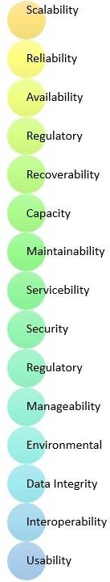 Examples of non-functional requirements include "how fast does the website load?" and "the site should load in 3 seconds when the number of simultaneous users is > 10,000". Non-functional requirements impose constraints on the system design, ensuring it meets quality attributes

**Fig 3.5 Non-functional requirements**

|  |  |
| --- | --- |
| * Usability requirement * Serviceability requirement * Manageability requirement * Recoverability requirement * Security requirement * Data Integrity requirement * Capacity requirement | * Availability requirement * Scalability requirement * Interoperability requirement * Reliability requirement * Maintainability requirement * Regulatory requirement * Environmental requirement |

**3.5.1 ADVANTAGES**

Non-functional requirements ensure the software system follows legal and compliance rules, providing several benefits:

* They ensure the reliability, availability, scalability and performance of the software system.
* They specify the quality attribute of the software.
* They ensure good user experience and ease of operating the software, and minimize the cost factor.
* They help in constructing the security policy of the software system.

**3.5.2 DISADVANTAGES**

Cons/drawbacks of Non-functional requirements:

* Non-functional requirement may affect the various high-level software subsystem.
* They require special consideration during the software architecture/high-level design phase which increases costs.
* Their implementation does not usually map to the specific software sub-system.
* It is tough to modify non-functional once you pass the architecture phase.
* It can be difficult to identify all non-functional requirements, especially when dealing with complex systems or new technologies.

**3.5.3 KEY LEARNINGS**

* Defining performance attributes of software systems.
* Types of non-functional requirements, such as scalability, capacity, availability, reliability, recoverability, and data integrity.
* Examples of non-functional requirements, like access control and security policies.
* Functional Requirement is a verb while Non-Functional Requirement is an attribute.
* Understanding the advantages and disadvantages of non-functional requirements.

## 3.6 SYSTEM STYDY

## 3.6.1 FEASIBILITY STUDY

A feasibility study assesses the operational, technical and economic merits of the proposed project. The feasibility study is intended to be a preliminary review of the facts to see if it is worthy of proceeding to the analysis phase. From the systems analyst perspective, the feasibility analysis is the primary tool for recommending whether to proceed to the next phase or to discontinue the project.

The feasibility study is a management-oriented activity. The objective of a feasibility study is to find out if an information system project can be done and to suggest possible alternative solutions.

Projects are initiated for two broad reasons:

1. Problems that lend themselves to systems solutions

2. Opportunities for improving through:

(a) upgrading systems

(b) altering systems

(c) installing new systems

A feasibility study should provide management with enough information to decide:

* Whether the project can be done
* Whether the final product will benefit its intended users and organization
* What are the alternatives among which a solution will be chosen
* Is there a preferred alternative?

Three key considerations involved in the feasibility analysis are:

* ECONOMICAL FEASIBILITY
* TECHNICAL FEASIBILITY
* OPERATIONAL FEASIBILITY

#### ECONOMICAL FEASIBILITY

Economic analysis could also be referred to as cost/benefit analysis. It is the most frequently used method for evaluating the effectiveness of a new system. In economic analysis the procedure is to determine the benefits and savings that are expected from a candidate system and compare them with costs. If benefits outweigh costs, then the

decision is made to design and implement the system. An entrepreneur must accurately weigh the cost versus benefits before taking an action.

Possible questions raised in economic analysis are:

* Is the system cost effective?
* Do benefits outweigh costs?
* The cost of doing full system study
* The cost of business employee time
* Estimated cost of hardware
* Estimated cost of software/software development
* Is the project possible, given the resource constraints?
* What are the savings that will result from the system?
* Cost of employees' time for study
* Cost of packaged software/software development
* Selection among alternative financing arrangements (rent/lease/purchase)

The concerned business must be able to see the value of the investment it is pondering before committing to an entire system study. If short-term costs are not overshadowed by long-term gains or produce no immediate reduction in operating costs, then the system is not economically feasible, and the project should not proceed any further. If the expected benefits equal or exceed costs, the system can be judged to be economically feasible. Economic analysis is used for evaluating the effectiveness of the proposed system.

The economic feasibility will review the expected costs to see if they are in-line with the projected budget or if the project has an acceptable return on investment. At this point, the projected costs will only be a rough estimate. The exact costs are not required to determine economic feasibility. It is only required to determine if it is feasible that the project costs will fall within the target budget or return on investment. A rough estimate of the project schedule is required to determine if it would be feasible to complete the systems project within a required timeframe. The required timeframe would need to be set by the organization.

#### TECHNICAL FEASIBILITY

A large part of determining resources has to do with assessing technical feasibility. It considers the technical requirements of the proposed project. The technical requirements are then compared to the technical capability of the organization. The systems project is considered technically feasible if the internal technical capability is sufficient to support the project requirements.

The analyst must find out whether current technical resources can be upgraded or added to in a manner that fulfils the request under consideration. This is where the expertise of system analysts is beneficial, since using their own experience and their contact with vendors they will be able to answer the question of technical feasibility.

The essential questions that help in testing the operational feasibility of a system include the following:

* Is the project feasible within the limits of current technology?
* Does the technology exist at all?
* Is it available within given resource constraints?
* Is it a practical proposition?
* Manpower- programmers, testers & debuggers
* Software and hardware
* Are the current technical resources sufficient for the new system?
* Can they be upgraded to provide to provide the level of technology necessary for the new system?
* Do we possess the necessary technical expertise, and is the schedule reasonable?
* Can the technology be easily applied to current problems?
* Does the technology have the capacity to handle the solution?
* Do we currently possess the necessary technology?

#### OPERATIONAL FEASIBILITY

Operational feasibility is dependent on human resources available for the project and involves projecting whether the system will be used if it is developed and implemented.

Operational feasibility is a measure of how well a proposed system solves the problems, and takes advantage of the opportunities identified during scope definition and how it satisfies the requirements identified in the requirements analysis phase of system development.

Operational feasibility reviews the willingness of the organization to support the proposed system. This is probably the most difficult of the feasibilities to gauge. In order to determine this feasibility, it is important to understand the management commitment to the proposed project. If the request was initiated by management, it is likely that there is management support and the system will be accepted and used. However, it is also important that the employee base will be accepting of the change.

The essential questions that help in testing the operational feasibility of a system include the following:

* Does current mode of operation provide adequate throughput and response time?
* Does current mode provide end users and managers with timely, pertinent, accurate and useful formatted information?
* Does current mode of operation provide cost-effective information services to the business?
* Could there be a reduction in cost and or an increase in benefits?
* Does current mode of operation offer effective controls to protect against fraud and to guarantee accuracy and security of data and information?
* Government regulations
* Does management support the project?
* Are the users not happy with current business practices?
* Will it reduce the time (operation) considerably?
* Have the users been involved in the planning and development of the project?
* Will the proposed system really benefit the organization? Does the overall response increase?
* Will accessibility of information be lost?
* Will the system affect the customers in considerable way?
* Legal aspects
* How do the end-users feel about their role in the new system?
* What end-users or managers may resist or not use the system?
* How will the working environment of the end-user change?
* Can or will end-users and management adapt to the change?

## MODULES

## In this project we include three modules are used,

* Task Schedular
* User
* Cloud

#### TASK SCHEDULAR

The Task Scheduler module is the core component responsible for managing and distributing incoming tasks (user requests) across available virtual machines (VMs) in the cloud environment. It plays a pivotal role in achieving efficient load balancing by ensuring that tasks are assigned to VMs in a manner that minimizes execution time, prevents resource overload or underutilization, and adheres to Service Level Agreement (SLA) parameters such as deadlines. In this project, the Task Scheduler implements the proposed Load Balancing Algorithm (LBA), which operates in a dynamic cloud environment where user requests arrive in random order and vary in size.

The Task Scheduler leverages the Cloudlet Scheduler Time Shared algorithm as its foundation, scheduling tasks based on two critical parameters: Deadline and Completion Time. It receives user requests from the User module via the top layer of the proposed framework and interacts with the Cloud module to allocate these tasks to VMs. The scheduler continuously monitors the status of VMs, identifying potential SLA violations (e.g., when a VM's completion time exceeds its deadline). In such cases, it triggers a migration technique, redistributing the workload to underutilized VMs by reconfiguring their MIPS (Million Instructions Per Second) to optimize resource usage. The Task Scheduler updates an allocation table to track VM status, workload distribution, and the number of assigned requests, ensuring a balanced and efficient system. This module directly contributes to reducing makespan and enhancing resource utilization, achieving an average utilization rate of 90% as demonstrated in the results.

#### 3.7.2 USER

The User module represents the front-end interface of the cloud system, facilitating interaction between clients and the cloud infrastructure. It is designed to handle requests from multiple users accessing the system through various devices, such as mobile phones, desktops, or tablets, over the Internet. This module operates within the top layer of the proposed framework and serves as the entry point for submitting tasks to the cloud environment.

Users generate requests that vary in complexity and resource requirements, such as computational tasks, data storage needs, or application-specific operations. These requests are forwarded to the Task Scheduler module for processing and allocation. The User module ensures seamless connectivity to the cloud services, enabling clients to access scalable, on-demand resources provided by the IaaS model. It is designed to support a diverse user base, reflecting real-world scenarios where requests arrive dynamically and unpredictably.

**3.7.3 CLOUD**

The Cloud module encompasses the backend infrastructure of the system, managing the physical and virtual resources necessary to execute user tasks. It operates within the bottom layer of the proposed framework and includes data centers, physical machines (servers), and virtual machines (VMs) that form the computational backbone of the IaaS model. This module is responsible for resource provisioning, virtualization, and workload execution, working in tandem with the Task Scheduler to achieve efficient load balancing.

The Cloud module hosts a pool of VMs, each with configurable resources such as CPU capacity (measured in MIPS), memory, and storage. It receives scheduled tasks from the Task Scheduler and allocates them to appropriate VMs based on the load balancing algorithm’s decisions. The module employs virtualization techniques to abstract physical resources into virtual entities, enabling dynamic scaling and efficient resource sharing among multiple tasks. When the Task Scheduler detects an SLA violation (e.g., an overloaded VM), the Cloud module facilitates workload migration by reallocating tasks to available VMs and adjusting resource configurations as needed. It maintains a high level of resource utilization (up to 90%, as per the project results) by ensuring that no VM remains idle or overburdened for extended periods. Additionally, the Cloud module interacts with the server health monitor and traffic monitor components to provide real-time data on VM performance and system status, enabling proactive load balancing and fault tolerance.

# 4. SYSTEM DESIGN

The load balancing algorithm is designed to distribute incoming traffic across multiple servers to ensure efficient use of resources, improve responsiveness, and maximize throughput. The algorithm aims to provide a highly available, scalable, and reliable solution for cloud computing tasks. The system consists of several components, including a load balancer, server cluster, traffic monitor, and server health monitor. The load balancer is the core component of the system, responsible for receiving incoming traffic and distributing it across multiple servers in the cluster based on the chosen load balancing algorithm. The traffic monitor is responsible for monitoring incoming traffic and providing feedback to the load balancer, while the server health monitor is responsible for monitoring the health and performance of each server in the cluster.

The load balancing algorithm used in this system is designed to provide a highly available, scalable, and reliable solution for cloud computing tasks. The algorithm takes into account factors such as server load, response time, and availability to select the most suitable server to handle incoming traffic. The system is designed to meet several requirements, including scalability, availability, performance, and security. The system should be able to scale horizontally to support increased traffic and server additions, and be available 99.99% of the time, with a maximum downtime of 5 minutes per year. The system should also be able to handle at least 10,000 concurrent connections with a response time of less than 1 second, and ensure the security and integrity of all traffic, encrypting all data using SSL/TLS and supporting secure authentication methods.

## 4.1 SYSTEM ARCHITECTURE

The system architecture consists of a load balancer, server cluster, traffic monitor, server health monitor, database, and API gateway. The load balancer receives incoming traffic and distributes it across multiple servers in the cluster based on the chosen load balancing algorithm. The traffic monitor provides feedback to the load balancer, while the server health monitor tracks the performance of each server. The database stores server information, and the API gateway provides a single entry point for incoming traffic, routing it to the load balancer. This architecture enables scalability, high availability, improved performance, and security, with features like encryption and secure authentication methods to protect against unauthorized access and data breaches.

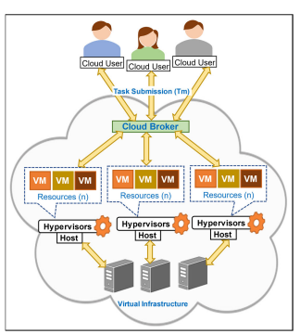

**Fig 4.1a System Architecture**

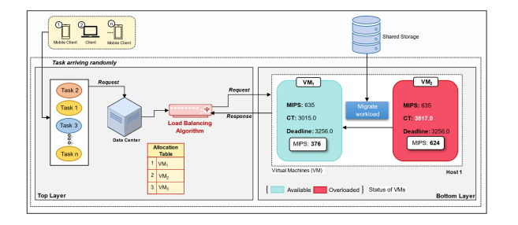

**Fig 4.1b System internal Architecture**

## UML DIAGRAMS

UML stands for Unified Modeling Language. UML is a standardized general- purpose modeling language in the field of object-oriented software engineering. The standard is managed, and was created by, the Object Management Group. The goal is for UML to become a common language for creating models of object oriented computer software. In its current form UML is comprised of two major components: a Meta-model and a notation. In the future, some form of method or process may also be added to or associated with, UML. The Unified Modeling Language is a standard language for specifying, Visualization, Constructing and documenting the artifacts of software system, as well as for business modeling and other non-software systems.

UML was created as a result of the chaos revolving around software development and documentation. In the 1990s, there were several different ways to represent and document software systems.

The UML represents a collection of best engineering practices that have proven successful in the modeling of large and complex systems. The UML is a very important part of developing objects oriented software and the software development process. The UML uses mostly graphical notations to express the design of software projects.

### 4.2.a GOALS:

The Primary goals in the design of the UML are as follows:

1. Provide users a ready-to-use, expressive visual modeling Language so that they can develop and exchange meaningful models.
2. Provide extendibility and specialization mechanisms to extend the core concepts.
3. Be independent of particular programming languages and development process.
4. Provide a formal basis for understanding the modeling language.
5. Encourage the growth of object oriented tools market.
6. Support higher level development concepts such as collaborations, frameworks, patterns and components.
7. Integrate best practices.

## USECASE DIAGRAM

A use case diagram in the Unified Modeling Language (UML) is a type of behavioral diagram defined by and created from a Use-case analysis. Its purpose is to present a graphical overview of the functionality provided by a system in terms of actors, their goals (represented as use cases), and any dependencies between those use cases. The main purpose of a use case diagram is to show what system functions are performed for which actor. Roles of the actors in the system can be depicted.

The main purpose of a use case diagram is to portray the dynamic aspect of a system. It accumulates the system's requirement, which includes both internal as well as external influences. It invokes persons, use cases, and several things that invoke the actors and elements accountable for the implementation of use case diagrams. It represents how an entity from the external environment can interact with a part of the system.

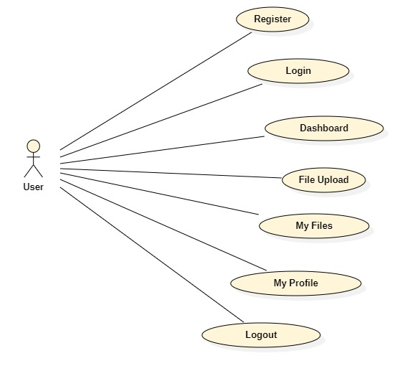

**Fig 4.2.1a Use Case Diagram**

**(user)**

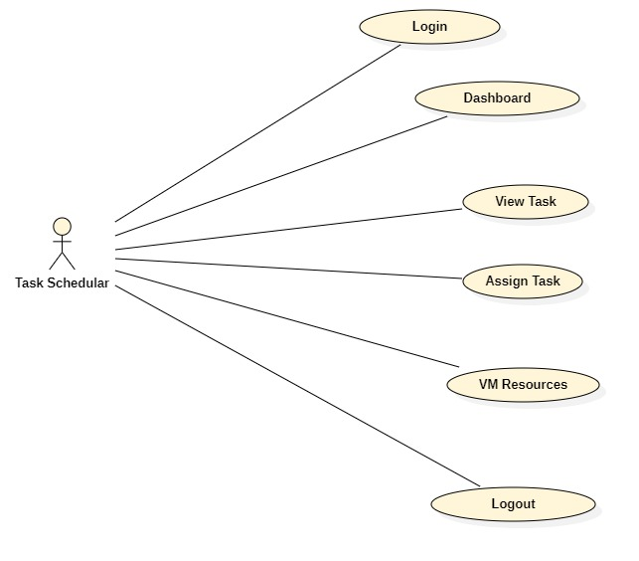

**Fig 4.2.1b Use Case Diagram**

**(Task Schedular)**

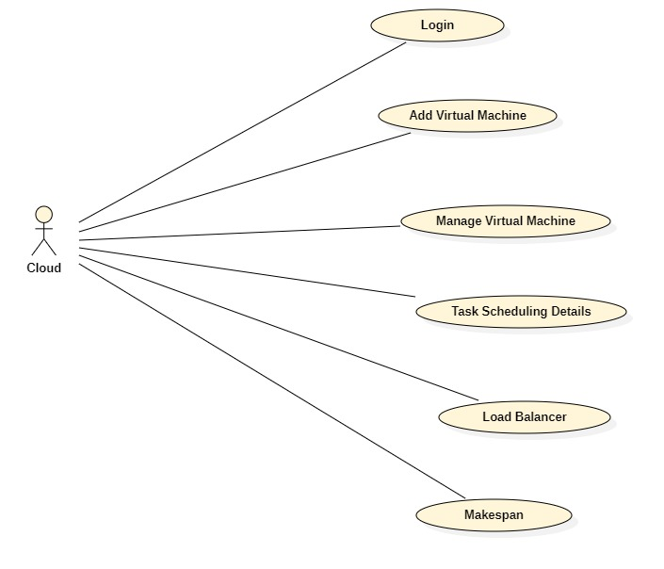

**Fig 4.2.1c Use Case Diagram**

**(Cloud)**

## 4.2.2 CLASS DIAGRAM

In software engineering, a class diagram in the Unified Modeling Language (UML) is a type of static structure diagram that describes the structure of a system by showing the system's classes, their attributes, operations (or methods), and the relationships among the classes. It explains which class contains information.

The class diagram depicts a static view of an application. It represents the types of objects residing in the system and the relationships between them. A class consists of its objects, and also it may inherit from other classes. A class diagram is used to visualize, describe, document various different aspects of the system, and also construct executable software code.

It shows the attributes, classes, functions, and relationships to give an overview of the software system. It constitutes class names, attributes, and functions in a separate compartment that helps in software development. Since it is a collection of classes, interfaces, associations, collaborations, and constraints, it is termed as a structural diagram. The main purpose of class diagrams is to build a static view of an application. It is the only diagram that is widely used for construction, and it can be mapped with object-oriented languages. It is one of the most popular UML diagrams.

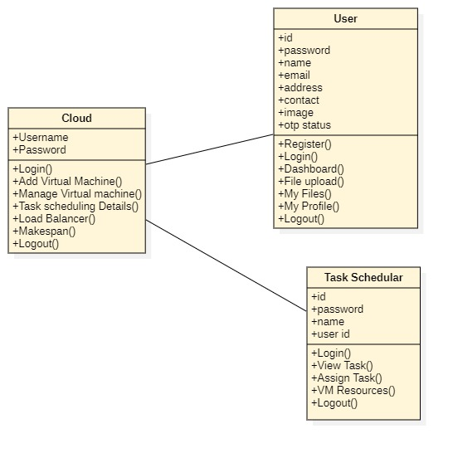

**Fig.4.2.2 Class Diagram**

## SEQUENCE DIAGRAM

A sequence diagram in Unified Modeling Language (UML) is a kind of interaction diagram that shows how processes operate with one another and in what order. It is a construct of a Message Sequence Chart. Sequence diagrams are sometimes called event diagrams, event scenarios, and timing diagrams.

The sequence diagram represents the flow of messages in the system and is also termed as an event diagram. It helps in envisioning several dynamic scenarios. It portrays the communication between any two lifelines as a time-ordered sequence of events, such that these lifelines took part at the run time. In UML, the lifeline is represented by a vertical bar, whereas the message flow is represented by a vertical dotted line that extends across the bottom of the page. It incorporates the iterations as well as branching.

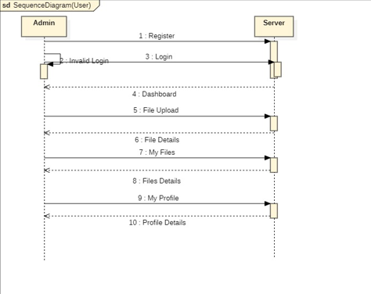

**Fig 4.2.3a Sequence Diagram**

**(user)**

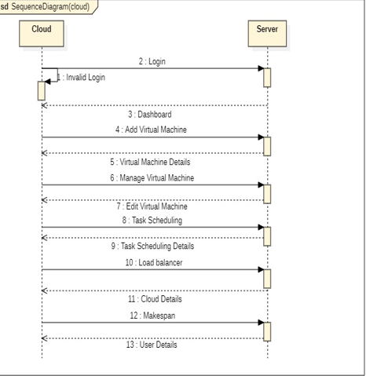

**Fig 4.2.3b Sequence Diagram**

**(Task Schedular)**

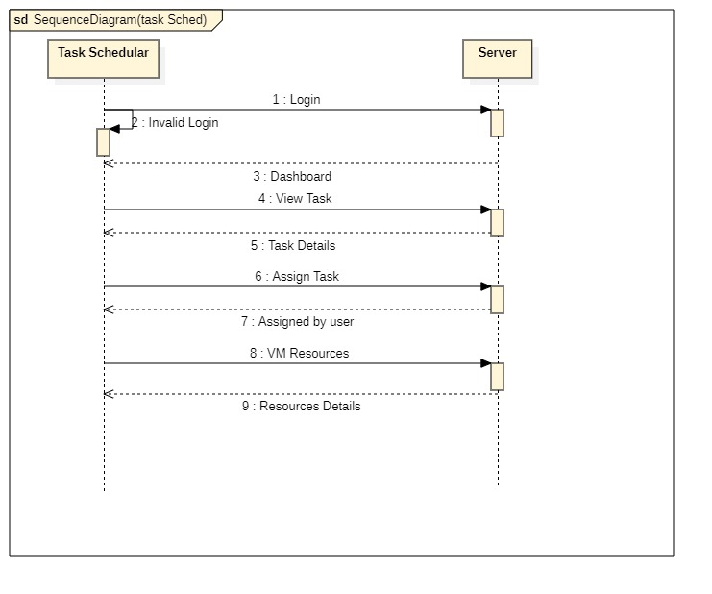

**Fig 4.2.3c Sequence Diagram**

**(Cloud)**

## 4.2.4 ACTIVITY DIAGRAM

Activity diagrams are graphical representations of workflows of stepwise activities and actions with support for choice, iteration and concurrency. In the Unified Modeling Language, activity diagrams can be used to describe the business and operational step-by-step workflows of components in a system. An activity diagram shows the overall flow of control.

In UML, the activity diagram is used to demonstrate the flow of control within the system rather than the implementation. It models the concurrent and sequential activities.

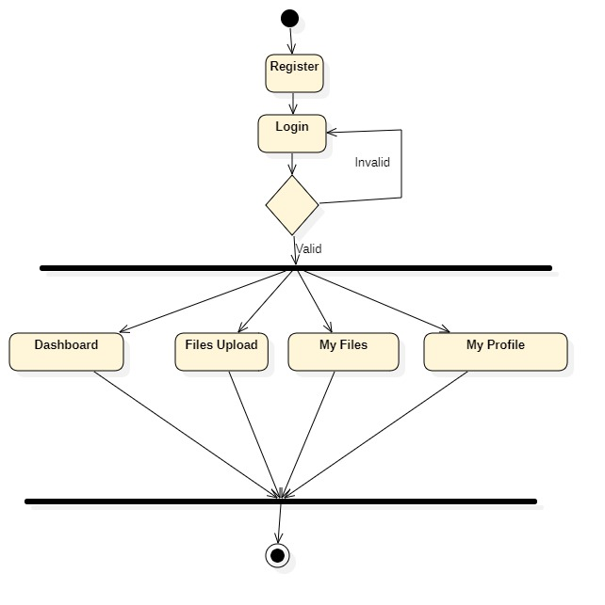

**Fig 4.2.4a Activity Diagram (User)**

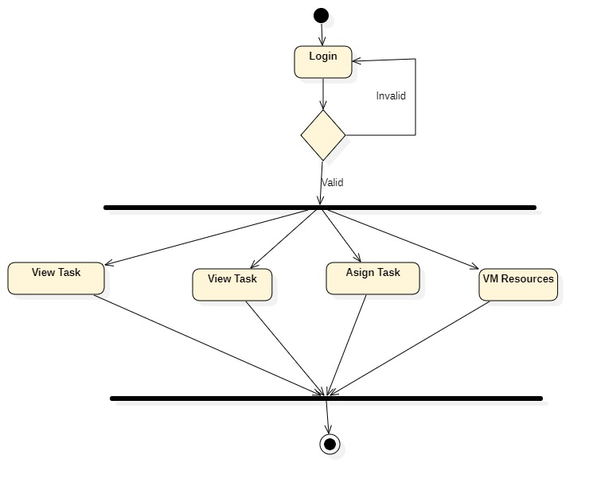

**Fig 4.2.4b Activity Diagram (Task Schedular)** 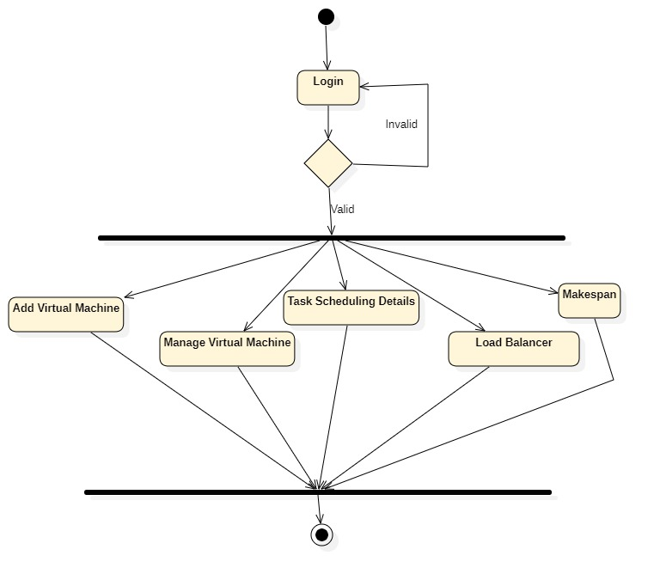

**Fig 4.2.4c Activity Diagram (Cloud)**

# SYSTEM IMPLEMENTATION

## 5.1 SOURCE CODE

**Cloudapp**

from turtle import down  
from django.shortcuts import render  
from django.shortcuts import get_object_or_404, redirect, render  
from userapp.models import *  
from mainapp.models import *  
from cloudapp.models import *  
from schedulerapp.models import *  
from django.db.models import Q  
from django.contrib import messages  
from django.shortcuts import render,redirect,get_object_or_404  
import requests  
import random  
import numpy as np  
import matplotlib.pyplot as plt  
from django.core.mail import EmailMultiAlternatives  
from lbaproject.settings import DEFAULT_FROM_EMAIL  
from mainapp.check_internet import *  
# from Power.settings import DEFAULT_FROM_EMAIL  
# import pandas as pd  
def cloud_login(request):  
 if request.method=='POST':  
 name=request.POST.get('name')  
 pwd=request.POST.get('pwd')  
 if name=='cloud' and pwd=='cloud':  
 messages.info(request,"login successfull")  
 return redirect('cloud_dashboard')  
 else:  
 messages.warning(request,'Something Wrong, Please try again.')  
 print('message')  
 return redirect ('cloud_login')  
 return render(request,'main/cloud-login.html')  
def cloud_dashboard(request):  
 users=userModel.objects.count()  
 uploads=fileModel.objects.count()  
 requests=requestModel.objects.count()  
 data1 = requestModel.objects.filter(vm_id=1).count()  
 print(data1)  
 data2 = requestModel.objects.filter(vm_id=2).count()  
 print(data2)  
 data3 = requestModel.objects.filter(vm_id=3).count()  
 return render(request,'cloud/cloud-dashboard.html',{'users':users,'uploads':uploads,'requests':requests,'data1':data1,'data2':data2,'data3':data3})  
def cloud_add_virtual_machine(request):  
 print("fffffffffffffffffffffffffffffffff")  
 if request.method=='POST':  
 print("fffffffffffffffffffffffffffffffff")  
 try:  
 count=vmModel.objects.all().count()  
 if count >= 3:  
 messages.warning(request,"You can not add more than 3.")  
 return redirect('cloud_add_virtual_machine')  
 except:  
 pass  
 vm_name=request.POST['vm_name']  
 print(vm_name)  
 os=request.POST['os']  
 print(os)  
 storage_type=request.POST['storage_type']  
 storage=request.POST['storage']  
 cpu=request.POST['cpu']  
 ram=request.POST['ram']  
 vm = vmModel.objects.create(vm_name=vm_name,os=os,storage=storage,cpu=cpu,ram=ram,storage_type=storage_type)  
 vm.save()  
 messages.info(request,'Added Successfully.')  
 return render(request,'cloud/cloud-add-virtual-machine.html')  
def cloud_edit_virtual_machine(request,id):   
 i = vmModel.objects.get(vm_id=id)  
 if request.method=='POST':  
 vm_name=request.POST['vm_name']  
 os=request.POST['os']  
 storage=request.POST['storage']   
 cpu=request.POST['cpu']  
 ram=request.POST['ram']  
 data = get_object_or_404(vmModel,vm_id=id)  
 data.vm_name = vm_name  
 data.storage = storage  
 data.os = os  
 data.cpu = cpu  
 data.ram = ram  
 data.save(update_fields=['vm_name','os','storage','cpu','ram'])  
 data.save()  
 messages.info(request,'Updated Successfully.')  
 return redirect('cloud_manage_virtual_machine')  
 return render(request,'cloud/cloud-edit-virtual-machine.html',{'i':i})  
def cloud_manage_virtual_machine(request):  
 data=vmModel.objects.all()  
 return render(request,'cloud/cloud-manage-virtual-machine.html',{'data':data})  
def cloud_on_status(request,id):  
 on=get_object_or_404(vmModel,vm_id=id)  
 on.status='ON'  
 on.save(update_fields=['status'])  
 on.save()  
 return redirect('cloud_manage_virtual_machine')  
  
def cloud_load_balancer(request):  
 file=vmModel.objects.all ()  
 data1 = requestModel.objects.filter(vm_id=1).count()  
 print(data1)  
 data2 = requestModel.objects.filter(vm_id=2).count()  
 print(data2)  
 data3 = requestModel.objects.filter(vm_id=3).count()  
 return render(request,'cloud/cloud-load-balancer.html',{'data1':data1,'data2':data2,'data3':data3,'file':file})  
def cloud_makespan(request):  
 app =requestModel.objects.all().order_by("-request_id")  
 print(app)  
 if request.method=='POST':  
 search=request.POST.get('search')  
 app=requestModel.objects.filter(Q(request_id__icontains=search) | Q(vm_id__icontains=search) | Q(file_name__icontains=search))  
 return render(request,'cloud/cloud-makespan.html',{'app':app})

**Mainapp**

{% load static %}

<!DOCTYPE html>+

<html lang="en">

<!-- Basic -->

<meta charset="utf-8">

<meta http-equiv="X-UA-Compatible" content="IE=edge">

<!-- Mobile Metas -->

<meta name="viewport" content="width=device-width, initial-scale=1">

<!-- Site Metas -->

<title>LBA</title>

<meta name="keywords" content="">

<meta name="description" content="">

<meta name="author" content="">

<!-- Site Icons -->

<link rel="shortcut icon" href="{% static 'main/images/favicon.ico' %}" type="image/x-icon" />

<link rel="apple-touch-icon" href="{% static 'main/images/apple-touch-icon.png' %}">

<link rel="stylesheet" href="{% static 'main/css/bootstrap.min.css' %}">

<!-- Site CSS -->

<link rel="stylesheet" href="{% static 'main/style.css' %}">

<link rel="stylesheet" href="{% static 'main/css/versions.css' %}">

<link rel="stylesheet" href="{% static 'main/css/responsive.css' %}">

<link rel="stylesheet" href="{% static 'main/css/custom.css' %}">

<!-- Modernizer for Portfolio -->

<script src="{% static 'main/js/modernizer.js' %}"></script>

</head>

<body class="host_version">

<!-- Right Control -->

<a class="new-effect carousel-control-next" href="#carouselExampleControls" role="button" data-slide="next">

<div id="overviews" class="section wb"> <div class="container"><div class="section-title row text-center"> <div class="col-md-8 offset-md-2">

<h2 style="color:orange"><ins>About</ins></h2>

</div> </div><!-- end title -->

<div class="row align-items-center"> <div class="col-xl-6 col-lg-6 col-md-12 col-sm-12"> <div class="message-box">

<h2 style="color:orange">Welcome to Load Balancing Algorithm</h2>

<p> </p>

<a href="#" class="hover-btn-new orange"><span>Learn More</span></a>

</div><!-- end messagebox --> </div><!-- end col -->

<div class="col-xl-6 col-lg-6 col-md-12 col-sm-12">

<div class="post-media wow fadeIn"> <img src="{% static 'main/images/th (2).jpg' %}" alt="" class="img-fluid img-rounded">

<p> Integer rutrum ligula eu dignissim laoreet. Pellentesque venenatis nibh sed tellus faucibus bibendum. Sed fermentum est vitae rhoncus molestie. Cum sociis natoque penatibus et magnis dis montes.</p>

<div class="footer-right">

<ul class="footer-links-soi">

<li><a href="#"><i class="fa fa-facebook"></i></a></li>

<li><a href="#"><i class="fa fa-github"></i></a></li>

<li><a href="#"><i class="fa fa-twitter"></i></a></li>

<li><a href="#"><i class="fa fa-dribbble"></i></a></li>

<li><a href="#"><i class="fa fa-pinterest"></i></a></li>

</ul><!-- end links --> </div> </div><!-- end clearfix --> </div><!-- end col -->

<div class="col-lg-4 col-md-4 col-xs-12">

<div class="widget clearfix">

<div class="widget-title">

<h3>Information Link</h3> </div>

<ul class="footer-links">

<li><a href="#">Home</a></li>

<li><a href="#">About</a></li>

<li><a href="#">Cloud</a></li>

<li><a href="#">User</a></li>

</ul><!-- end links --> </div><!-- end clearfix --> </div><!-- end col -->

<div class="col-lg-4 col-md-4 col-xs-12"> <div class="widget clearfix">

<div class="widget-title"> <h3>Contact Details</h3></div>

<ul class="footer-links">

<p><i class="fa fa-phone-alt me-3"></i>Pin Code:500074. T.S.</p>

<p><i class="fa fa-phone-alt me-3"></i>8555887986</p>

<div class="footer-center">

<p class="footer-company-name">>Copyright © 2022, All rights reserved | <a href="#"></a> Designed & Developed by : <a href="#"> FZ INFOTECH</a></p>

</div> </div> </div><!-- end container --></div><!-- end copyrights -->

<a href="#" id="scroll-to-top" class="dmtop global-radius"><i class="fa fa-angle-up"></i></a>

<!-- ALL JS FILES -->

<script src="{% static 'main/js/all.js' %}"></script>

<!-- ALL PLUGINS -->

<script src="{% static 'main/js/custom.js' %}"></script>

<script src="{% static 'main/js/timeline.min.js' %}"></script>

<script>

timeline(document.querySelectorAll('.timeline'), {

forceVerticalMode: 700,

mode: 'horizontal',

verticalStartPosition: 'left',

visibleItems: 4 });

</script>

</body>

</html>

**Schedularapp**

from re import M  
from django.shortcuts import render  
from ast import Pass  
from dataclasses import field  
from tkinter.tix import COLUMN  
from urllib import request  
from email.headerregistry import Address  
from unicodedata import name  
from django.contrib import messages  
from tabnanny import check  
from django.shortcuts import render  
from cloudapp.models import *  
from userapp.models import *  
from schedulerapp.models import *  
from django.shortcuts import render,redirect,get_object_or_404  
from django.http import HttpResponseRedirect, HttpResponse  
from django.urls import reverse  
from django.shortcuts import render  
from django.db.models import Q, F, Sum  
import random  
import requests  
from cryptography.fernet import Fernet  
from mainapp.check_internet import *  
from datetime import datetime  
import time  
def scheduler_login(request):  
 if request.method=='POST':  
 name=request.POST.get('name')  
 pwd=request.POST.get('pwd')  
 if name=='scheduler' and pwd=='scheduler':  
 messages.info(request,"login successfull")  
 return redirect('scheduler_dashboard')  
 else:  
 messages.warning(request,'Something Wrong, Please try again.')  
 return redirect ('scheduler_login')  
 return render(request,'scheduler/scheduler-login.html')  
def scheduler_dashboard(request):  
 users=userModel.objects.count()  
 uploads=fileModel.objects.count()  
 requests=requestModel.objects.count()  
 pendings=fileModel.objects.filter(status='Pending').count()  
 pendings=fileModel.objects.filter(status='Assigned').count()  
 vm=vmModel.objects.count()  
 return render(request,'scheduler/scheduler-dashboard.html',{'users':users,'uploads':uploads,'requests':requests,'pendings':pendings,'vm':vm})  
def scheduler_assign_task(request):  
 app =vmModel.objects.all()  
 data = fileModel.objects.all().order_by("-file_id")  
requestModel.objects.create(file_name=file_name,file=file,file_size=file_size,user_id=user_id,owner_id=owner_id,description=description,file_type=file_type,file_id=file_id)  
return render(request,'scheduler/scheduler-assign-task.html',{'data':data,'app':app})  
def scheduler_task(request,id):  
 user_id=request.session["user_id"]  
 filedetails = fileModel.objects.get(file_id= id)  
 file_id=filedetails.file_id   
 file_name = filedetails.file_name  
 file=filedetails.file  
 file_size = filedetails.file_size  
 file_type=filedetails.file_type  
 print(file_type)  
 file=filedetails.file  
 description=filedetails.description  
 file_uploaded_date=filedetails.file_uploaded_date  
 file_uploaded_time=filedetails.file_uploaded_time  
 print(description)   
 now =datetime.now()  
 print(now,'time success')  
 if fileModel.objects.filter(file_id=id , status="Assigned"):   
 messages.warning(request,"File Already Assigned")  
 return redirect('scheduler_assign_task')   
 else: requestModel.objects.create(file_name=file_name,file=file,file_size=file_size,user_id=user_id,description=description, file_type=file_type,file_id=file_id,vm_id=vm.vm_id,file_uploaded_date=file_uploaded_date,file_uploaded_time=file_uploaded_time,requested_time=time)  
 def scheduler_manage_vm_resourses(request):  
 data = requestModel.objects.all().order_by("-request_id")  
 return render(request,'scheduler/scheduler-manage-vm-resourses.html',{'data':data})  
def scheduler_view_task(request):  
 data = fileModel.objects.all().order_by("-file_id")  
 return render(request,'scheduler/scheduler-view-task.html',{'data':data})

## 5.2 ALGORITHMS

The load balancing algorithm proposed in this project is designed to optimize resource allocation and task scheduling in cloud data centers, specifically within the Infrastructure as a Service (IaaS) model. It leverages dynamic scheduling techniques and migration strategies to enhance the efficiency of cloud computing tasks, addressing challenges like workload imbalance and Service Level Agreement (SLA) violations.

**5.2.1 Proposed Load Balancing Algorithm (LBA)**

The core of this project is a novel Load Balancing Algorithm (LBA) that operates within a two-layer framework to manage tasks in a dynamic cloud environment. It is tailored to handle random task arrivals, varying task sizes, and SLA constraints, ensuring efficient resource utilization and reduced execution times.

**Key Components:**

* **Cloudlet Scheduler Time Shared**: This scheduling mechanism assigns tasks (cloudlets) to virtual machines (VMs) in a time-shared manner, considering their arrival time, size, and SLA-defined deadlines. It forms the foundation for initial task distribution.
* **Load Balancer**: Acts as the primary decision-making entity in the top layer, monitoring VM performance and initiating workload migration when SLA violations occur (e.g., when completion time exceeds deadline).
* **Migration Mechanism**: Dynamically reallocates tasks from overloaded VMs to underutilized ones by reconfiguring their MIPS (Million Instructions Per Second), ensuring balanced resource usage.
* **Allocation Table**: A data structure that tracks VM status (e.g., "violated" or "normal"), the number of assigned tasks, and resource allocation details, updated after each migration or task completion.

The algorithm excels in dynamic environments by adapting to unpredictable workloads and prioritizing SLA compliance, achieving an average resource utilization of 90% compared to 78% for the existing Dynamic LBA.

**5.2.2 Task Scheduling and SLA Monitoring**

Before load balancing occurs, tasks are scheduled based on critical parameters derived from the SLA and VM performance.

* **Deadline**: The maximum allowable time for task completion, as specified in the SLA.
* **Completion Time**: Estimated time to finish a task on a VM, calculated based on task size and VM capacity (MIPS).
* **Monitoring Process**: The algorithm continuously compares the Time to Complete (TTC) with the deadline. If TTC ≤ Deadline, no action is taken; if TTC > Deadline, the VM is flagged as "violated," triggering load balancing actions.

This step ensures that the system proactively addresses potential SLA breaches, a key differentiator from static scheduling methods.

**5.2.3 Workload Migration and Resource Reconfiguration**

When an SLA violation is detected, the algorithm employs a migration strategy to redistribute the workload:

* **Violation Detection**: Identifies VMs where TTC exceeds the deadline (e.g., VM2 in the project example).
* **Target Selection**: Chooses an underutilized VM capable of handling additional load without violating its own SLA constraints.
* **MIPS Reconfiguration**: Adjusts the processing capacity of both the overloaded and target VMs (e.g., reducing MIPS on the source VM and increasing it on the target) to balance the load.
* **Task Transfer**: Moves excess workload to the target VM, ensuring seamless execution continuity.

This process minimizes makespan (total task completion time) and prevents resource wastage, enhancing overall system efficiency.

**5.2.4 Model Implementation and Environment**

The algorithm is implemented using a robust technical stack to simulate and test its performance in a cloud environment:

* **Programming Language**: Python 3.10, leveraging its data processing and algorithmic capabilities.
* **Framework**: Django, enabling a web-based interface for user interaction (e.g., file uploads as tasks) and backend logic for scheduling and balancing.
* **Database**: MySQL, storing task metadata, VM states, and allocation tables.
* **Simulation**: Likely tested in a tool like CloudSim (common in cloud research), though not explicitly stated, to model VM behavior and workload dynamics.

The system supports a practical application where users upload files (tasks), and the algorithm schedules them across VMs, reflecting real-world cloud usage scenarios.

**5.2.5 Performance Evaluation**

The LBA’s performance is evaluated against the existing Dynamic Load Balancing Algorithm using key metrics:

* **Resource Utilization**: Achieved 90% on average, a significant improvement over Dynamic LBA’s 78%, indicating better resource exploitation.
* **Execution Time**: Reduced due to efficient task allocation and migration, though exact figures are not detailed in the provided excerpt.
* **Makespan**: Minimized by preventing VM overload and optimizing workload distribution.
* **SLA Compliance**: Fewer violations, as the algorithm dynamically adjusts to meet deadlines.

These metrics were assessed in a dynamic setting with random task arrivals and varying sizes, demonstrating the algorithm’s robustness and adaptability.

**5.2.6 Data Visualization and User Interface**

To aid understanding and system management, the project includes visualization and interaction components:

* **Visualization**: While not explicitly detailed, similar projects often use tools like Matplotlib or Plotly to graph resource utilization, task completion times, and VM load distribution.
* **User Interface**: Built with HTML5, CSS3, and JavaScript via Django, allowing users to upload tasks (e.g., files) and view their processing status, enhancing usability for cloud service providers and end-users.

This feature bridges the technical algorithm with practical application, making it accessible for real-world deployment.

# 6. SYSTEM TESTING

The purpose of testing is to discover errors. Testing is the process of trying to discover every conceivable fault or weakness in a work product. It provides a way to check the functionality of components, sub assemblies, assemblies and/or a finished product It is the process of exercising software with the intent of ensuring that the Software system meets its requirements and user expectations and does not fail in an unacceptable manner. There are various types of test. Each test type addresses a specific testing requirement.

## TYPES OF TESTS

## Types of Software Testing: Different Testing Types with Details

## FUNCTIONAL TESTING

## There are four main types of functional testing.

#### 6.1.1 UNIT TESTING

Unit testing is a type of software testing which is done on an individual unit or component to test its corrections. Typically, Unit testing is done by the developer at the application development phase. Each unit in unit testing can be viewed as a method, function, procedure, or object. Developers often use test automation tools such as NUnit, Xunit, JUnit for the test execution.

Unit testing is important because we can find more defects at the unit test level.

**For example**, there is a simple calculator application. The developer can write the unit test to check if the user can enter two numbers and get the correct sum for addition functionality.

#### 6.1.2 INTEGRATION TESTING

Integration testing is a type of software testing where two or more modules of an application are logically grouped together and tested as a whole. The focus of this type of testing is to find the defect on interface, communication, and data flow among modules. Top-down or Bottom-up approach is used while integrating modules into the whole system.

This type of testing is done on integrating modules of a system or between systems. For example, a user is buying a flight ticket from any airline website. Users can see flight details and payment information while buying a ticket, but flight details and payment processing are two different systems. Integration testing should be done while integrating of airline website and payment processing system.

#### 6.1.3 SYSTEM TESTING

System testing is types of testing where tester evaluates the whole system against the specified requirements.

**a) End to End Testing**

sIt involves testing a complete application environment in a situation that mimics real-world use, such as interacting with a database, using network communications, or interacting with other hardware, applications, or systems if appropriate.

**For example**, a tester is testing a pet insurance website. End to End testing involves testing of buying an insurance policy, LPM, tag, adding another pet, updating credit card information on users’ accounts, updating user address information, receiving order confirmation emails and policy documents.

**b) Black Box Testing**

Blackbox testing is a software testing technique in which testing is performed without knowing the internal structure, design, or code of a system under test. Testers should focus only on the input and output of test objects.

Detailed information about the advantages, disadvantages, and types of Black Box testing can be found here.

**c) Sanity Testing**

Sanity testing is performed on a system to verify that newly added functionality or bug fixes are working fine. Sanity testing is done on stable build. It is a subset of the regression test.

**For example**, a tester is testing a pet insurance website. There is a change in the discount for buying a policy for second pet. Then sanity testing is only performed on buying insurance policy module.

#### 6.1.4 ACCEPTANCE TESTING

Acceptance testing is a type of testing where client/business/customer test the software with real time business scenarios.

The client accepts the software only when all the features and functionalities work as expected. This is the last phase of testing, after which the software goes into production. This is also called User Acceptance Testing (UAT).

**a) Alpha Testing**

Alpha testing is a type of acceptance testing performed by the team in an organization to find as many defects as possible before releasing software to customers.

**For example**, the pet insurance website is under UAT. UAT team will run real-time scenarios like buying an insurance policy, buying annual membership, changing the address, ownership transfer of the pet in a same way the user uses the real website. The team can use test credit card information to process payment-related scenarios.

**b) Beta Testing**

Beta Testing is a type of software testing which is carried out by the clients/customers. It is performed in the Real Environment before releasing the product to the market for the actual end-users.

Beta Testing is carried out to ensure that there are no major failures in the software or product, and it satisfies the business requirements from an end-user perspective. Beta Testing is successful when the customer accepts the software.

**c) Operational acceptance testing (OAT)**

Operational acceptance testing of the system is performed by operations or system administration staff in the production environment. The purpose of operational acceptance testing is to make sure that the system administrators can keep the system working properly for the users in a real-time environment.

**NON-FUNCTIONAL TESTING**

Here are four main types of non-functional testing.

##### SECURITY TESTING

It is a type of testing performed by a special team. Any hacking method can penetrate the system.

Security Testing is done to check how the software, application, or website is secure from internal and/or external threats. This testing includes how much software is secure from malicious programs, viruses and how secure & strong the authorization and authentication processes are.

**6.1.6 PERFORMANCE TESTING**

Performance testing is a type of Black Box testing used to check how stable and fast an application is under load. Stability checks if the app works properly when many users are active. Response time measures how quickly it reacts to user actions.

**a) Load Testing**

Load testing is done by applying a number of users that the application is designed to handle or fewer.

**b) Stress Testing**

Stress testing is done by applying more users than the app is built for, to see how it performs under pressure.

**6.1.7 USABILITY TESTING**

Usability testing checks how the application looks and feels from the user’s point of view. It ensures the system is easy to use, well-designed, and user-friendly.

**For example**: If you are testing a mobile stock trading app, you check things like:

* Is it easy to use with one hand?
* Are buttons and scrollbars easy to interact with?

The main goal is to make sure the user can easily understand and use the application without confusion.

##### 6.1.8 COMPATIBILITY TESTING

This is a testing type in which it validates how software behaves and runs in a different environment, web servers, hardware, and network environment.

**7. RESULTS**

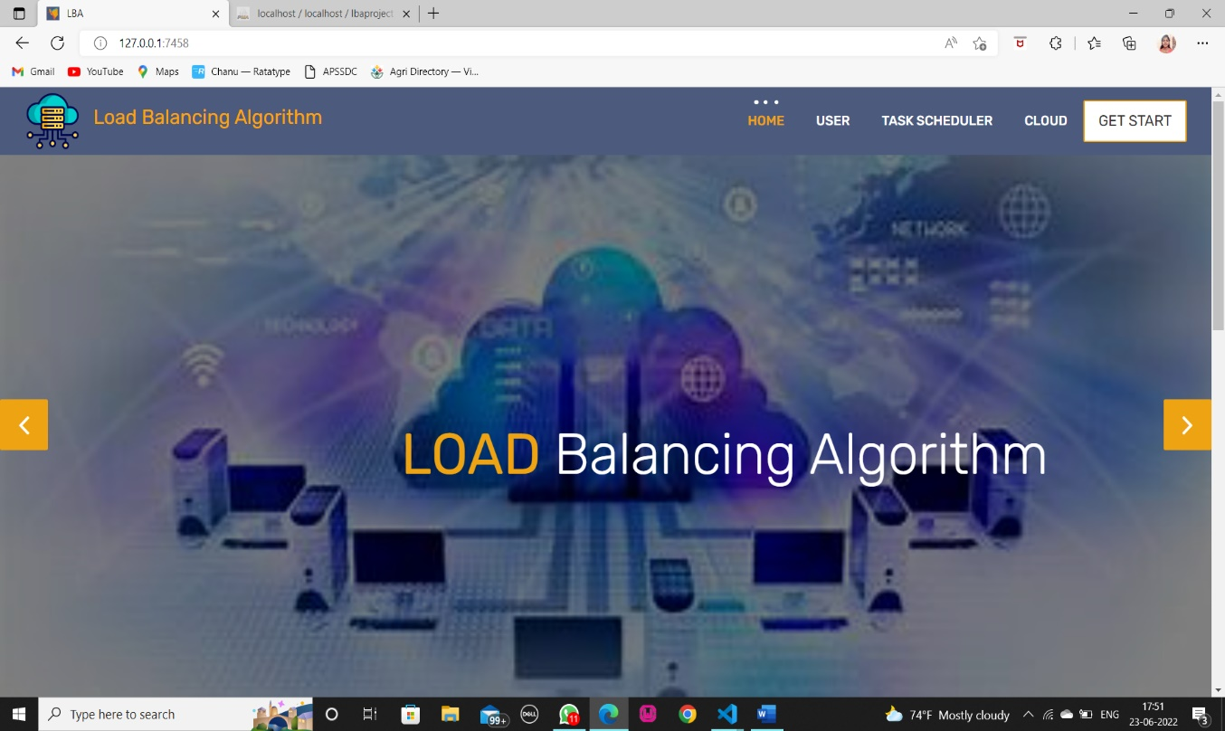

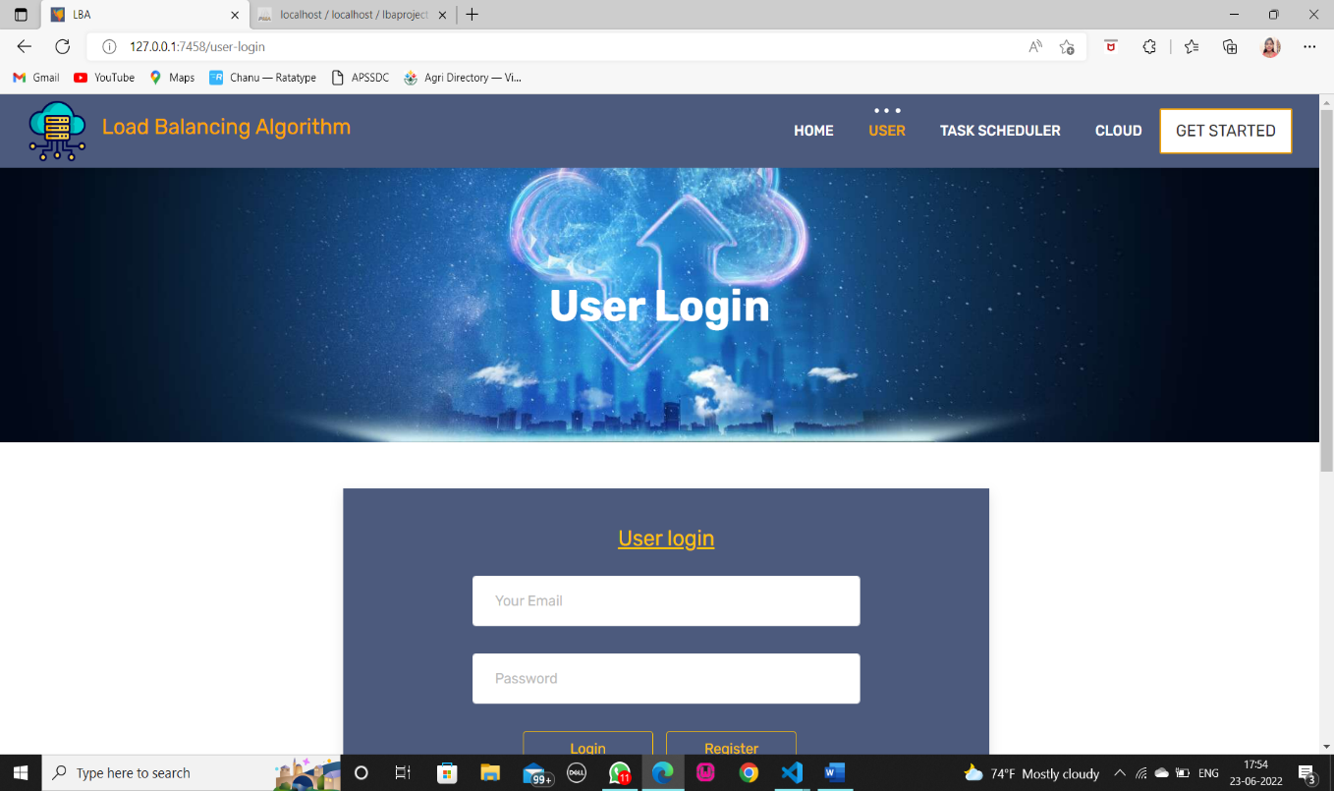

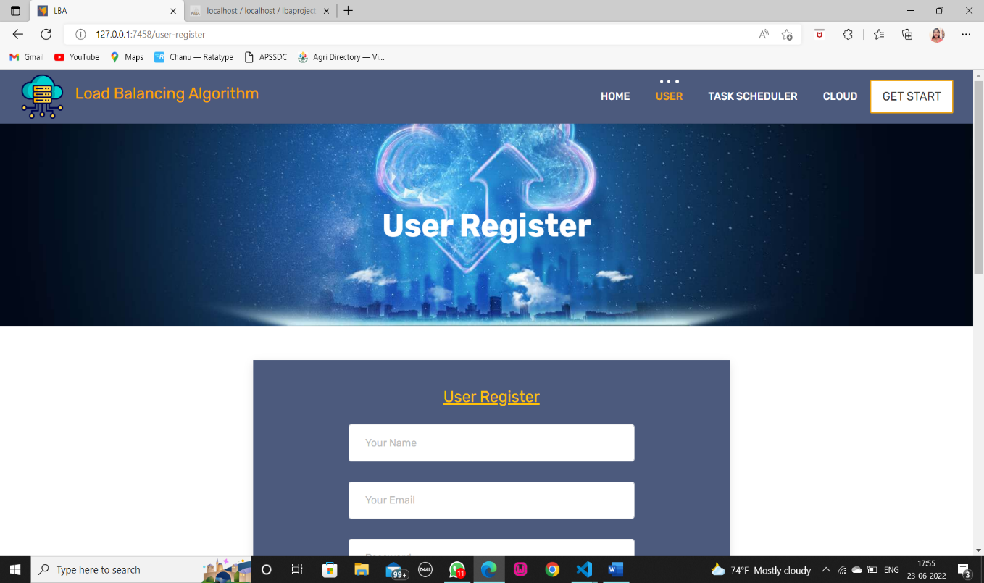

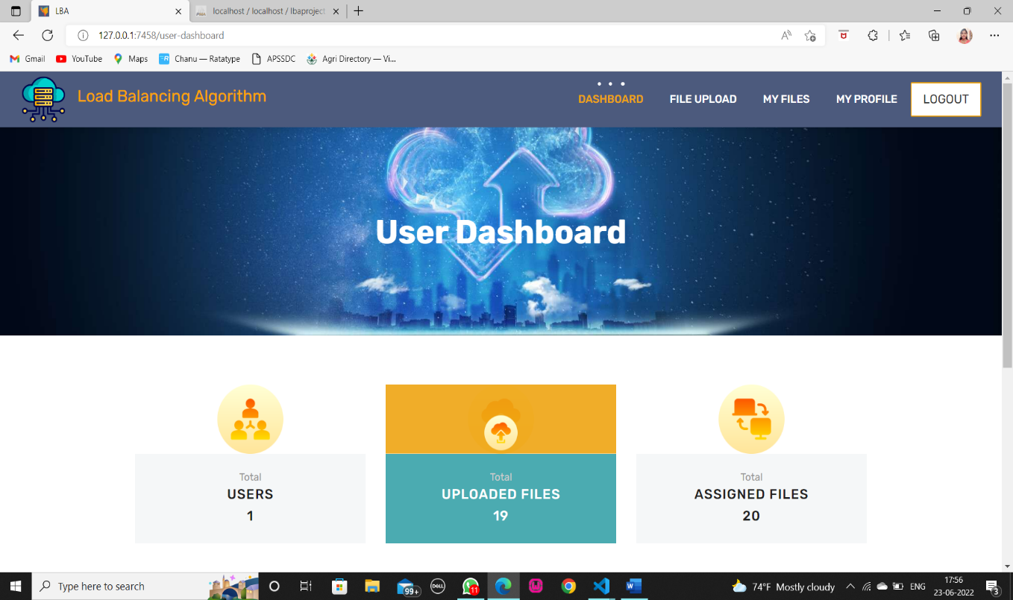

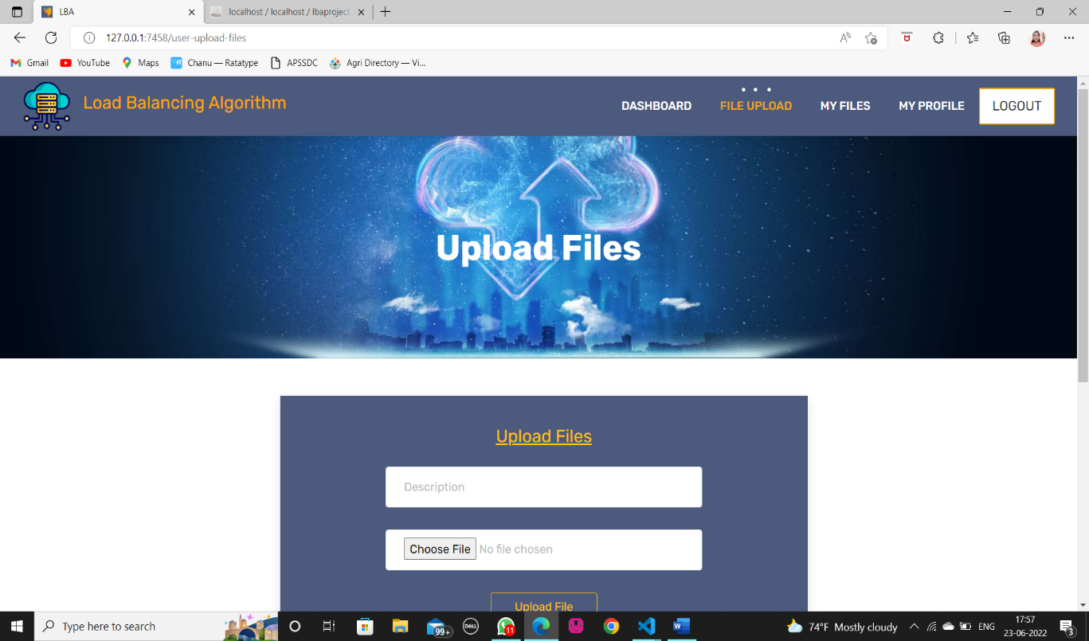

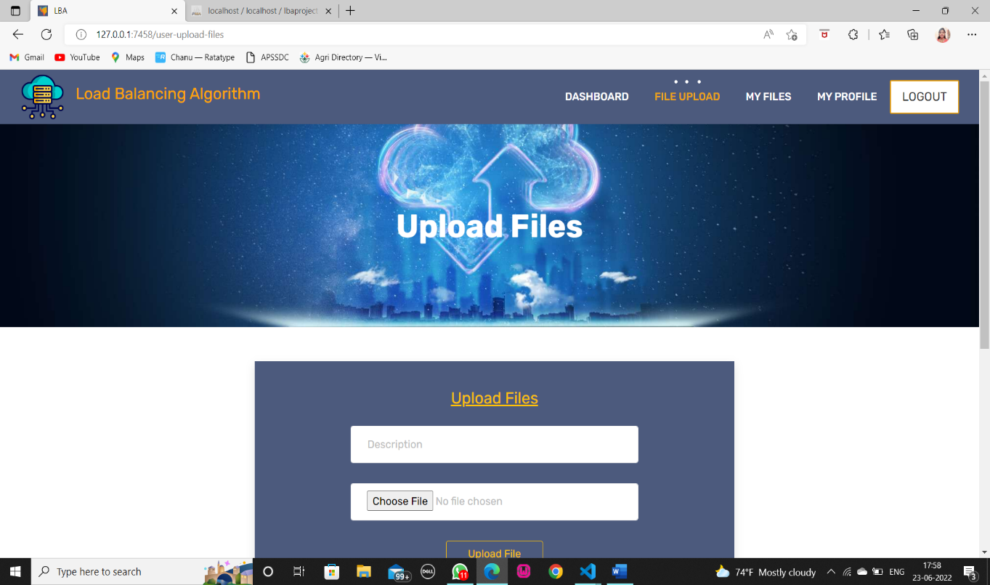

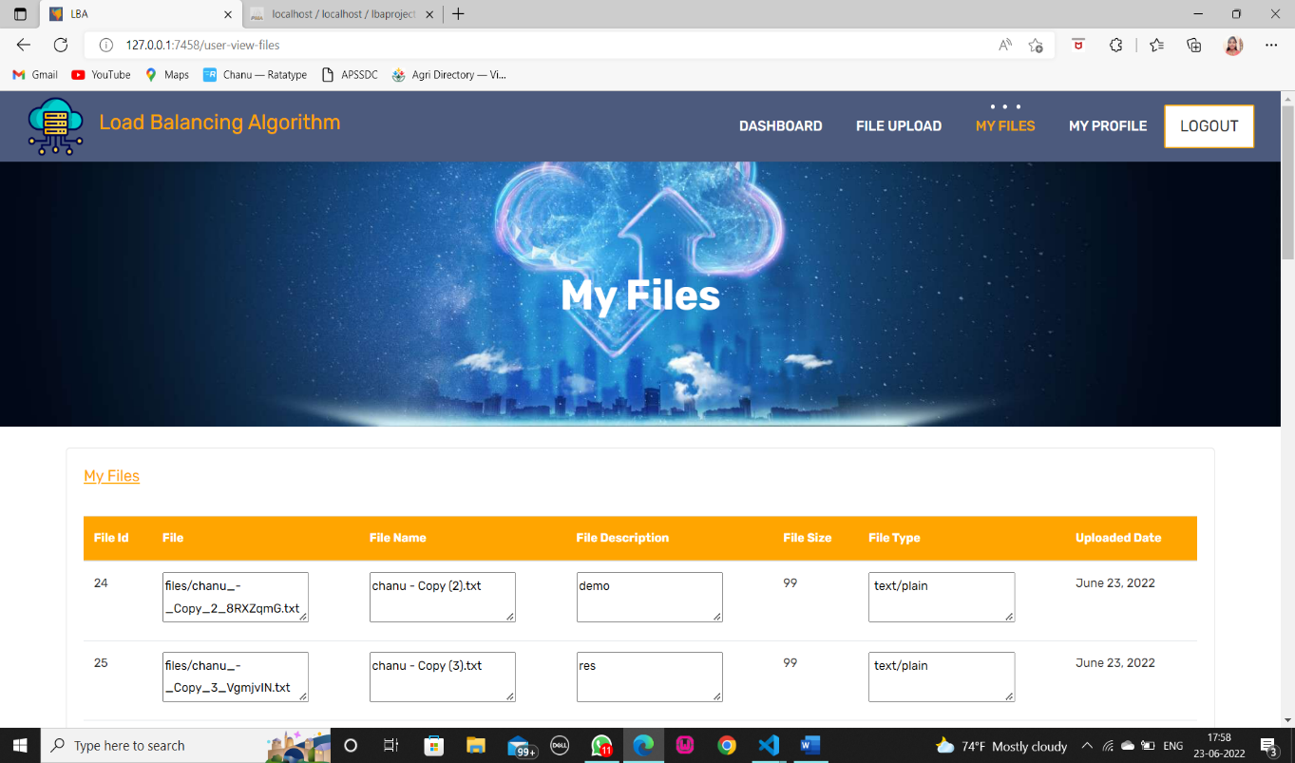

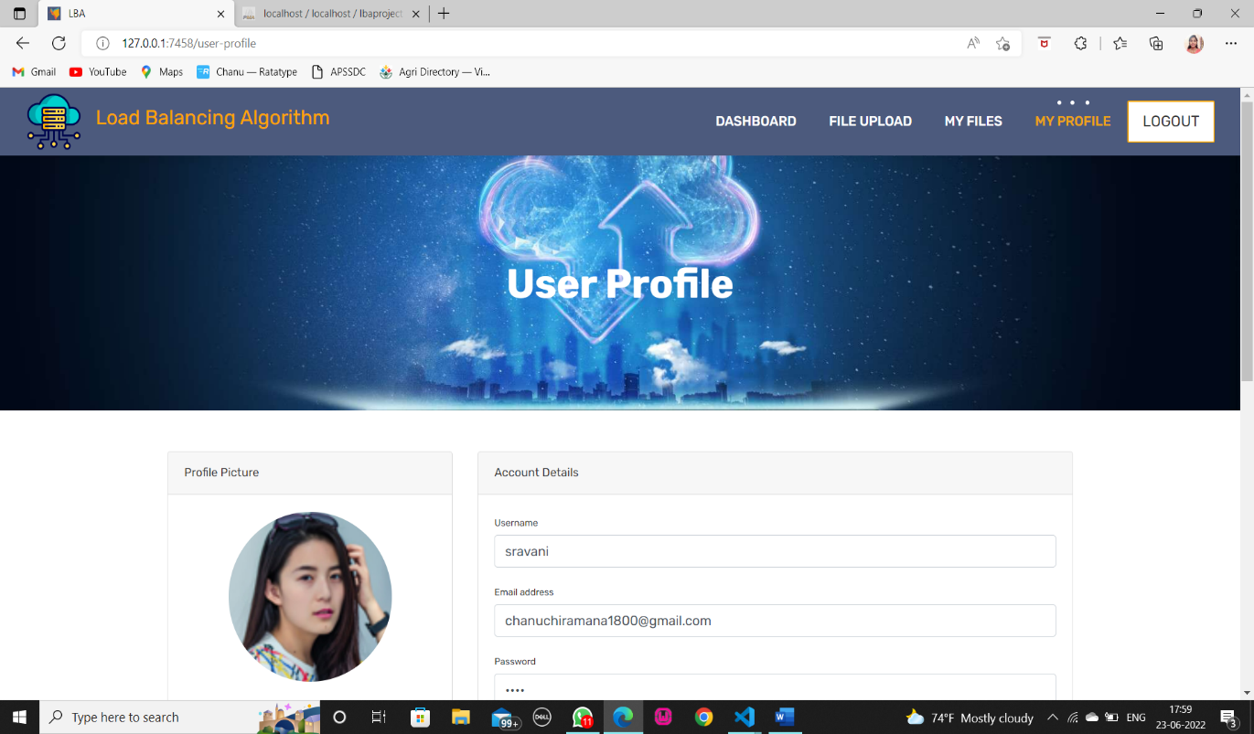

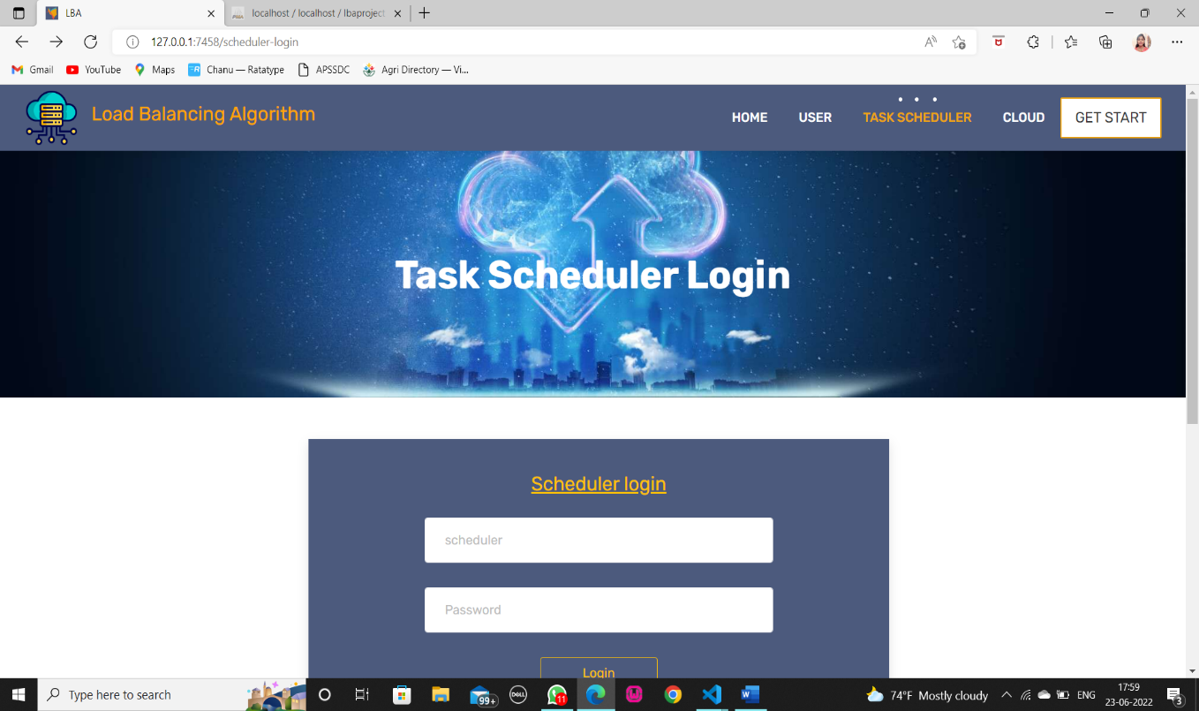

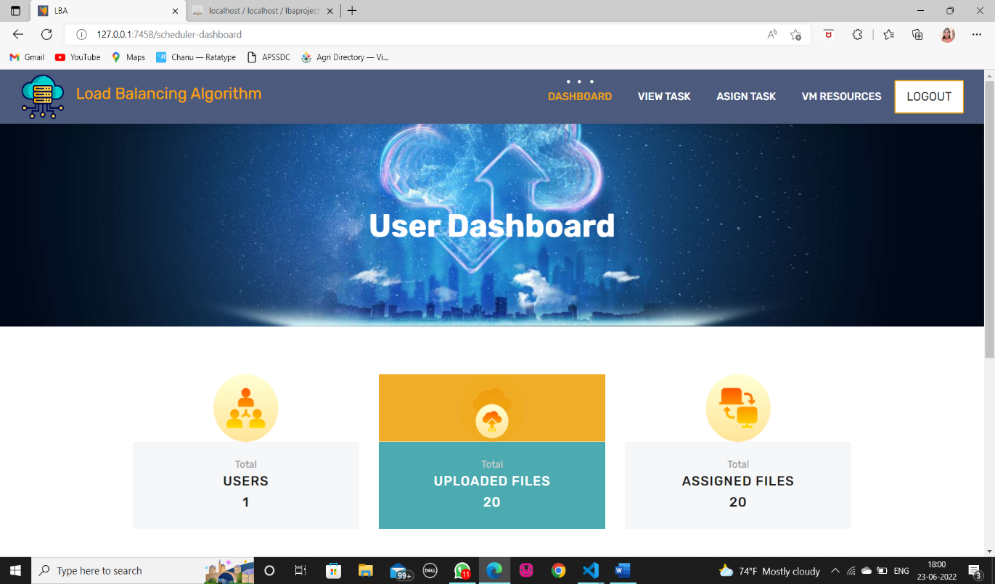

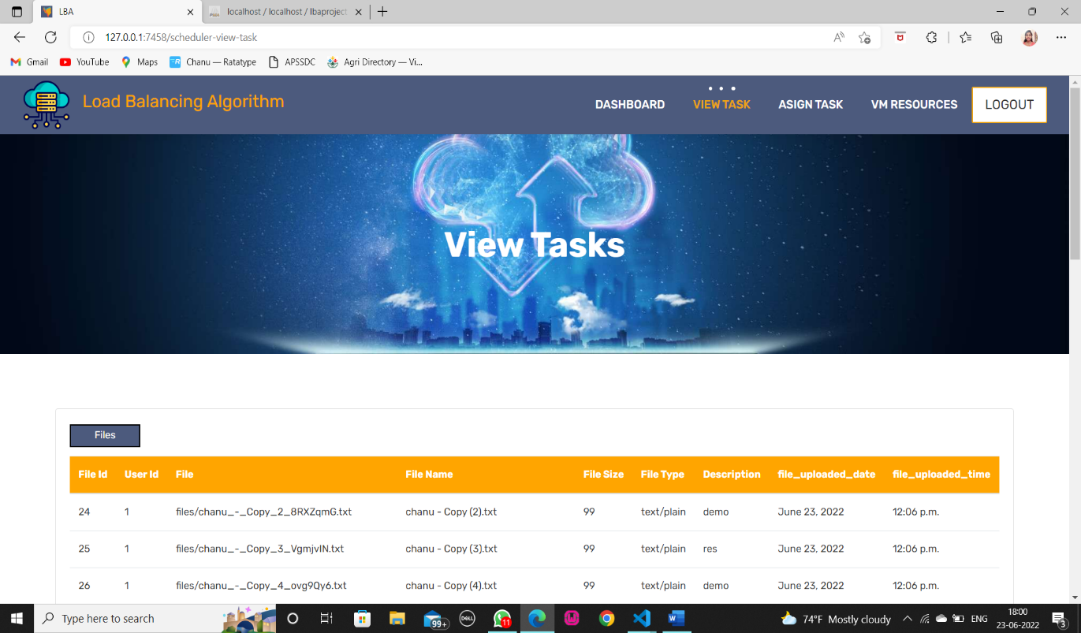

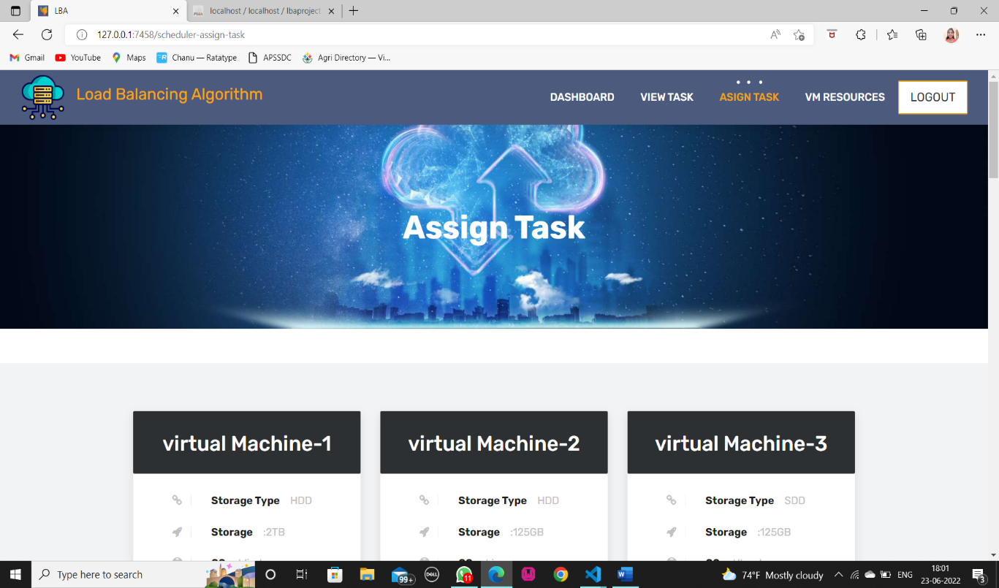

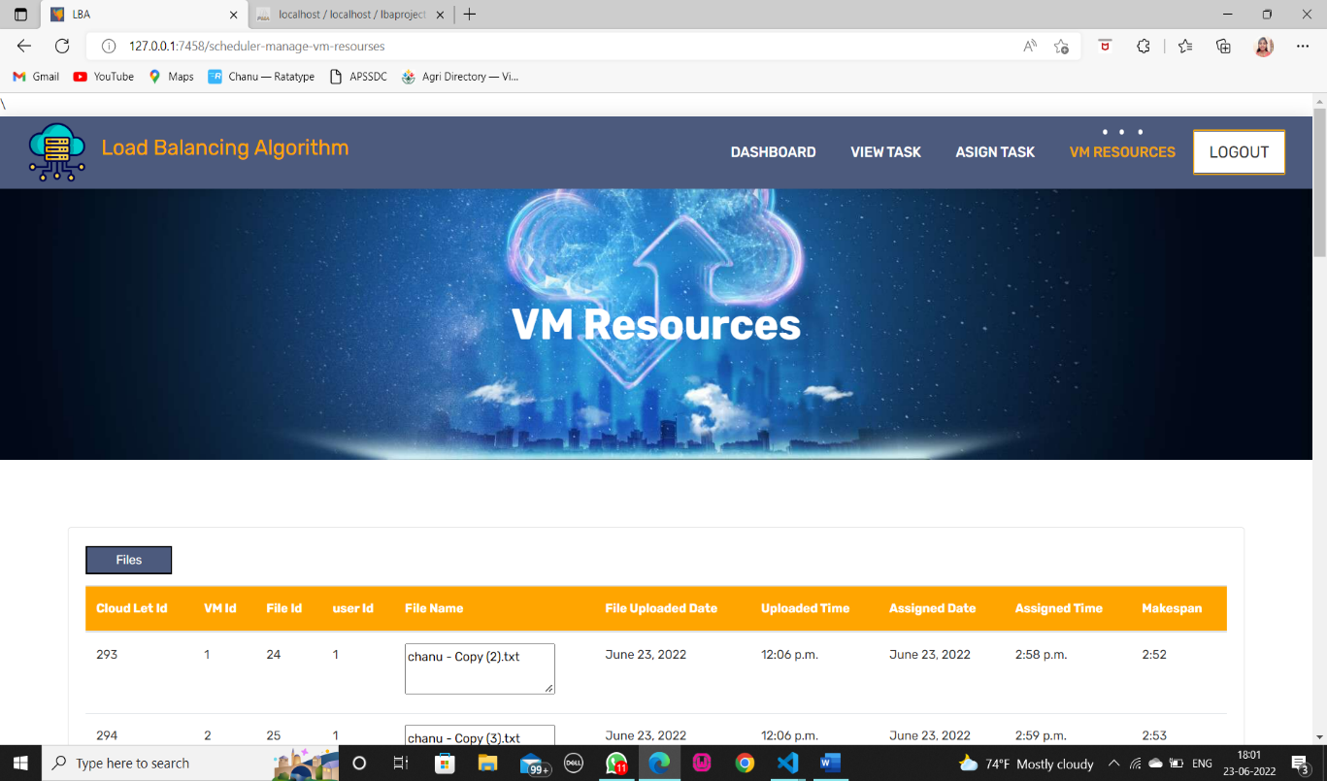

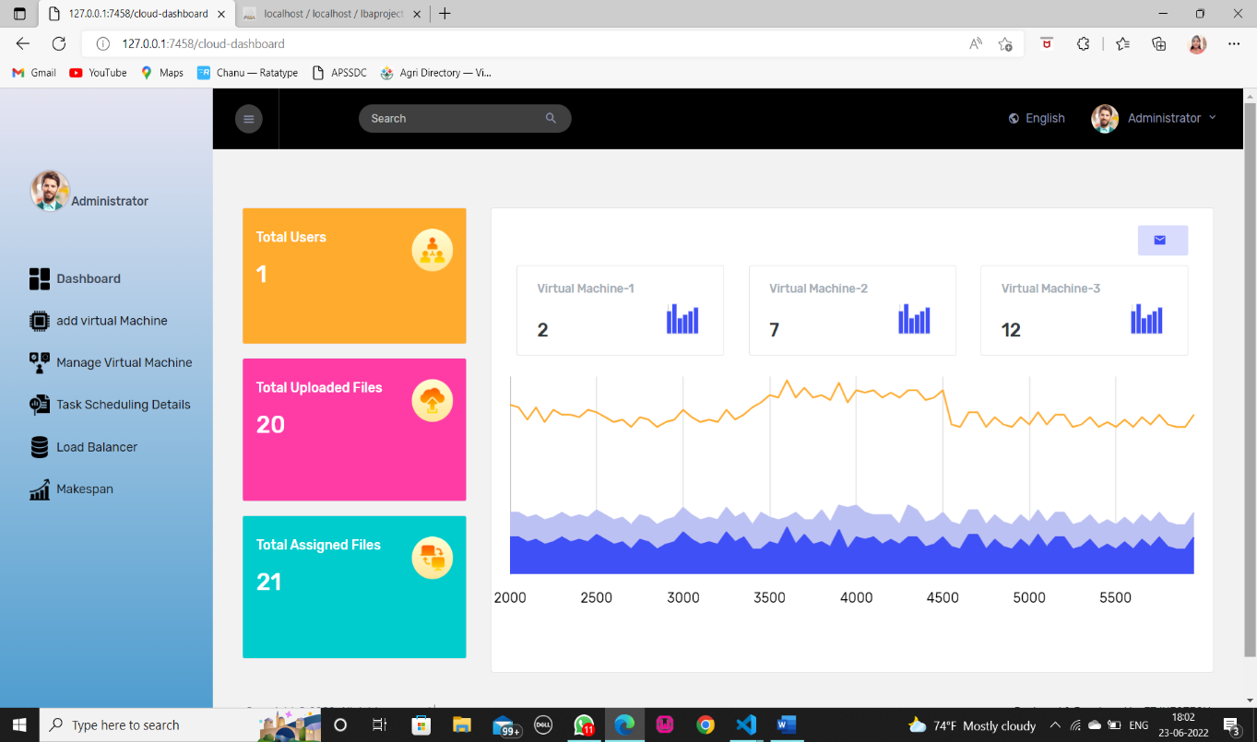

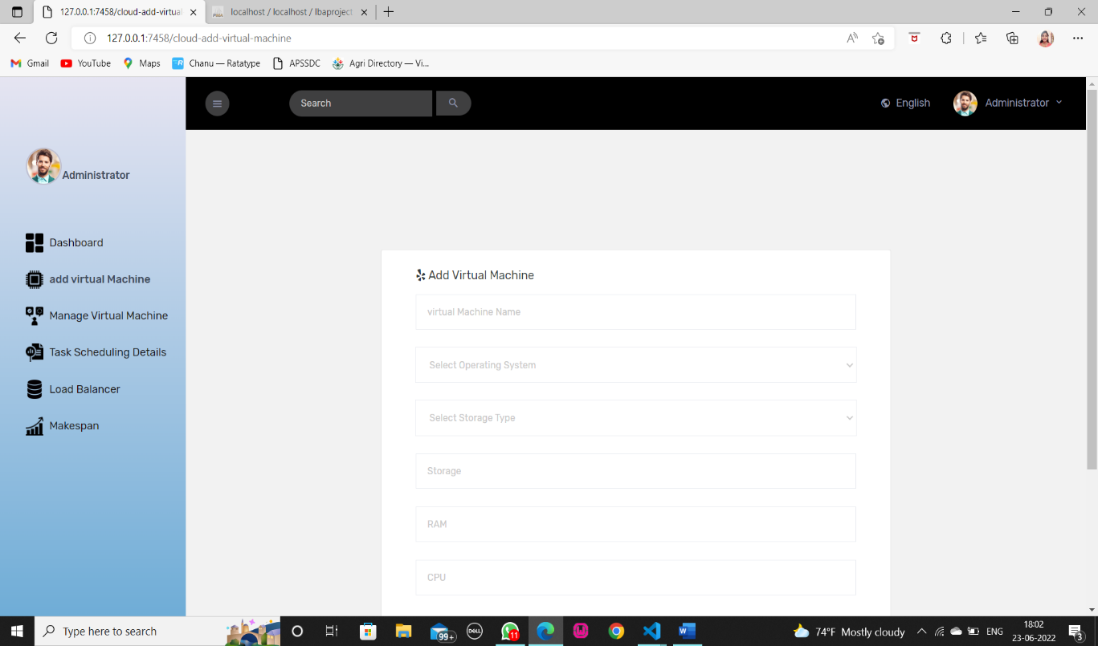

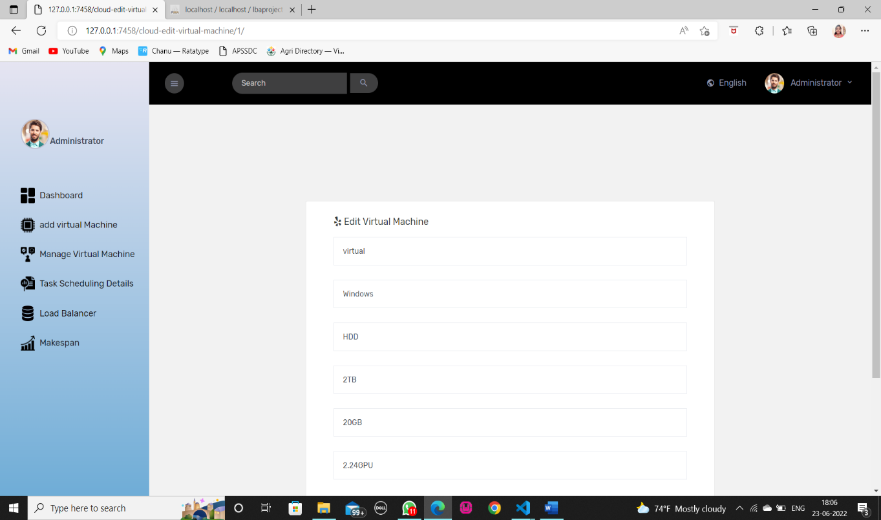

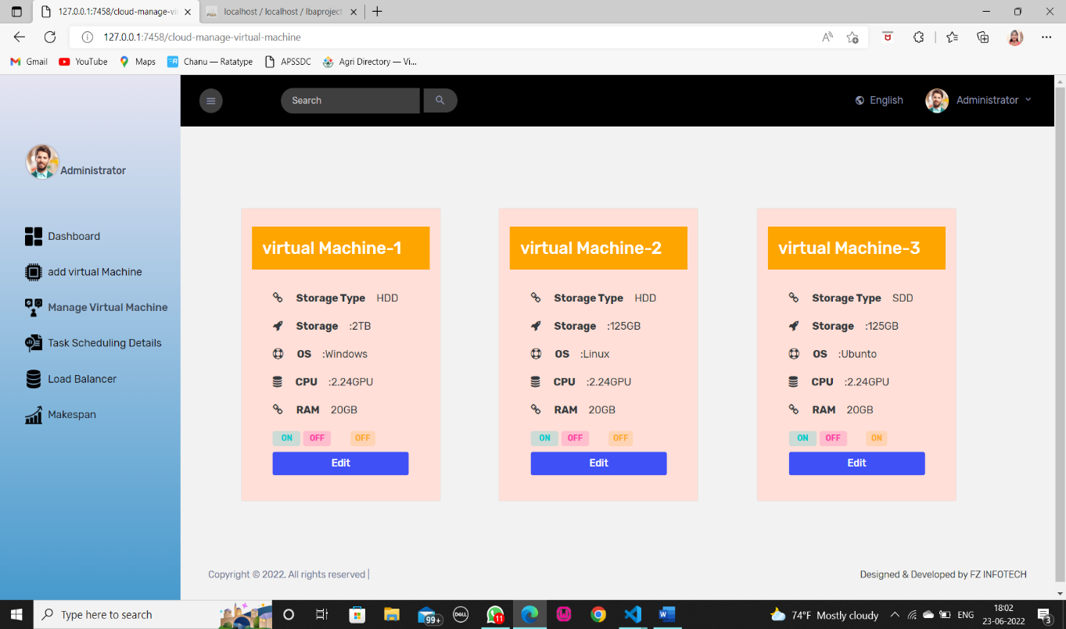

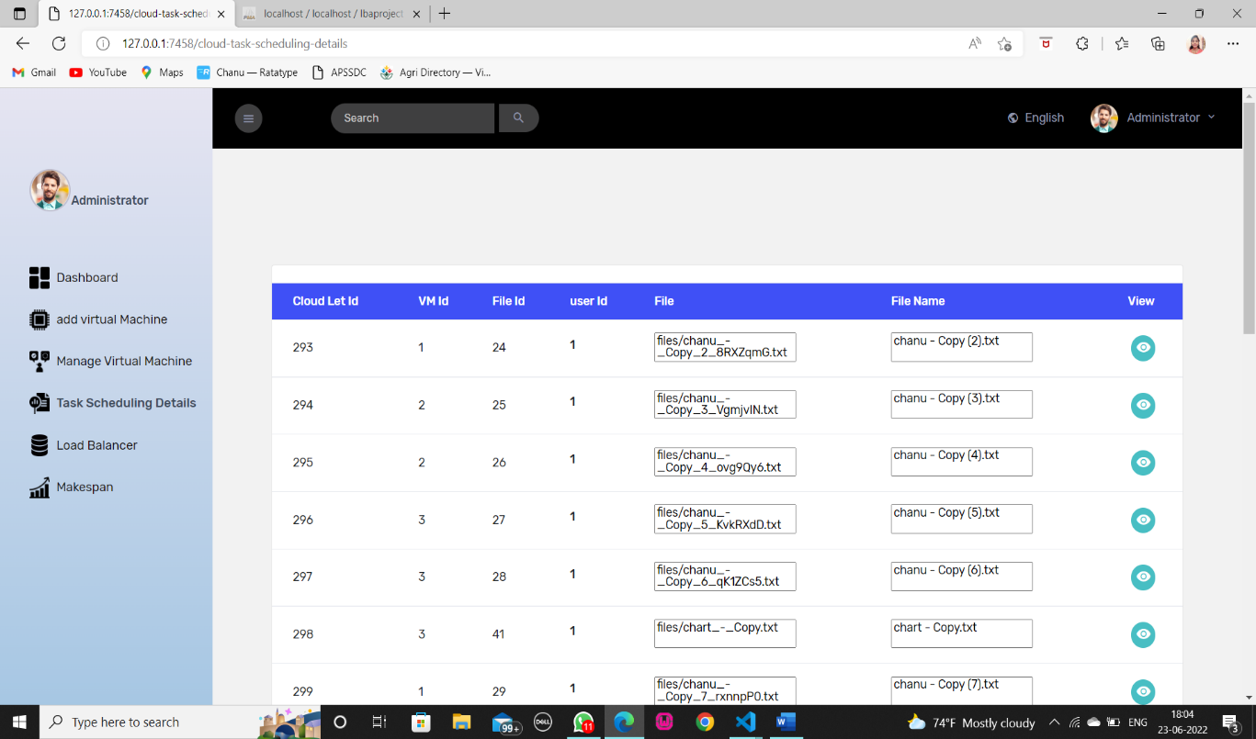

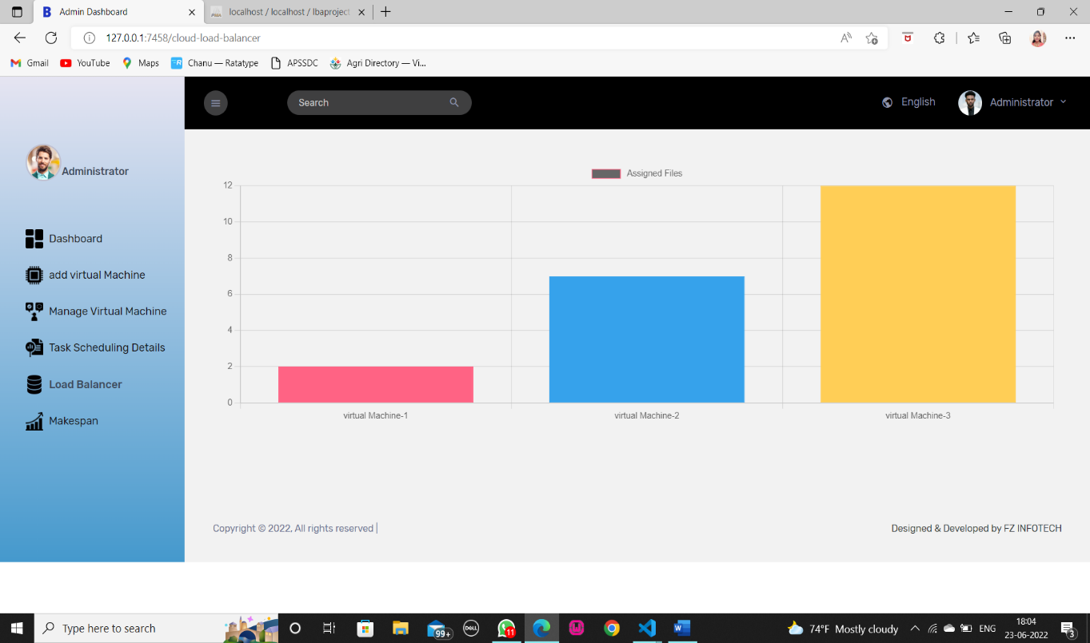

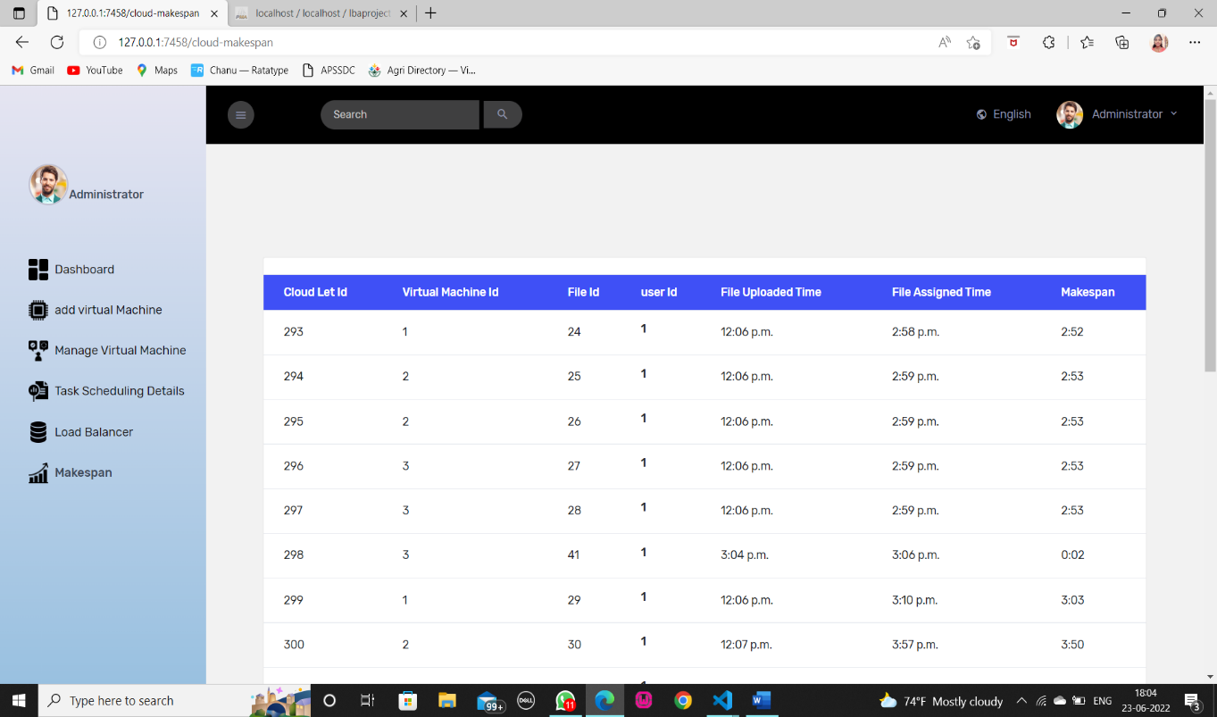

**8. CONCLUSION**

This section concludes the paper by highlighting the findings and obtained results from the proposed LB algorithm. As we saw from the literature, task scheduling highly contributes to balancing the load in a cloud environment. Improving the Load Balancing process through Task Scheduling can result in efficient utilization of cloud resources. The objective of this paper was to provide an enhanced Load Balancing algorithm. Results proved that our algorithm reduces Makespan and provide efficient resource utilization of 90% compared to existing Dynamic LBA. It also shows that the proposed algorithm can function in a dynamic cloud environment where user requests arrive in random order and where there are many changes in the length of the user requests. The algorithm is also able to handle large size requests compared to the existing approach. The algorithm address SLA violation of VMs by reallocating resources to execute tasks efficiently. In the future, authors will work to optimize the cloud resources further and enhance cloud-based application performance, such as considering more SLA parameters. For example, the algorithm will be tested based on the number of violations and the migration count for better performance. Also, the algorithm will be comprehensively compared to other existing algorithms in the literature.

# 9. FUTURE WORK

While this project has successfully designed and evaluated a load balancing algorithm for enhancing the efficiency of cloud computing tasks in data centers, there are several avenues for future research and development. To further improve the algorithm's performance and adaptability, future work could focus on integrating machine learning techniques to dynamically adjust load balancing decisions based on real-time workload patterns and data center conditions.

Exploring the application of this algorithm in edge computing environments and emerging cloud computing paradigms, such as serverless computing and containerization, could provide valuable insights into its versatility and scalability. By pursuing these research directions, we can continue to refine and expand the capabilities of our load balancing algorithm, ultimately contributing to more efficient, resilient, and sustainable cloud computing infrastructures.

# 10. REFERENCES

[1] H. Shukur, S. Zeebaree, R. Zebari, D. Zeebaree, O. Ahmed, and A. Salih, ‘‘Cloud computing virtualization of resources allocation for distributed systems,’’ J. Appl. Sci. Technol. Trends, vol. 1, no. 3, pp. 98–105, Jun. 2020, doi: 10.38094/jastt1331.

[2] M. Agarwal and G. M. Saran Srivastava, ‘‘Cloud computing: A paradigm shift in the way of computing,’’ Int. J. Mod. Educ. Comput. Sci., vol. 9, no. 12, pp. 38–48, Dec. 2017, doi: 10.5815/ijmecs.2017.12.05.

[3] N. Zanoon, ‘‘Toward cloud computing: Security and performance,’’ Int. J. Cloud Comput.: Services Archit., vol. 5, no. vol. 5, nos. 5–6, pp. 17–26, Dec. 2015, doi: 10.5121/ijccsa.2015.5602.

[4] C. T. S. Xue and F. T. W. Xin, ‘‘Benefits and challenges of the adoption of cloud computing in business,’’ Int. J. Cloud Comput.: Services Archit., vol. 6, no. 6, pp. 1–15, Dec. 2016, doi: 10.5121/ijccsa.2016.6601.

[5] D. A. Shafiq, N. Jhanjhi, and A. Abdullah, ‘‘Proposing a load balancing algorithm for the optimization of cloud computing applications,’’ in Proc. 13th Int. Conf. Math., Actuarial Sci., Comput. Sci. Statist. (MACS), Dec. 2019, pp. 1–6, doi: 10.1109/MACS48846.2019.9024785.

[6] S. K. Mishra, B. Sahoo, and P. P. Parida, ‘‘Load balancing in cloud computing: A big picture,’’ J. King Saud Univ.–Comput. Inf. Sci., vol. 32, no. 2, pp. 149–158, 2020, doi: 10.1016/j.jksuci.2018.01.003.

[7] I. Odun-Ayo, M. Ananya, F. Agono, and R. Goddy-Worlu, ‘‘Cloud computing architecture: A critical analysis,’’ in Proc. 18th Int. Conf. Comput. Sci. Appl. (ICCSA), Jul. 2018, pp. 1–7, doi: 10.1109/ICCSA.2018.8439638.

[8] A. Jyoti, M. Shrimali, and R. Mishra, ‘‘Cloud computing and load balancing in cloud computing -survey,’’ in Proc. 9th Int. Conf. Cloud Comput., Data Sci. Eng. (Confluence), Jan. 2019, pp. 51–55, doi: 10.1109/confluence.2019.8776948.

[9] S. H. H. Madni, M. S. Abd Latiff, M. Abdullahi, S. M. Abdulhamid, and M. J. Usman, ‘‘Performance comparison of heuristic algorithms for task scheduling in IaaS cloud computing environment,’’ PLoS ONE, vol. 12, no. 5, May 2017, Art. no. e0176321, doi: 10.1371/journal.pone.0176321.

[10] M. Adhikari and T. Amgoth, ‘‘Heuristic-based load-balancing algorithm for IaaS cloud,’’ Future Gener. Comput. Syst., vol. 81, pp. 156–165, Apr. 2018, doi: 10.1016/j.future.2017.10.035.

[11] B. Singh and G. Singh, ‘‘A study on virtualization and hypervisor in cloud computing,’’ Int. J. Comput. Sci. Mobile Appl., vol. 6, no. 1, pp. 17–22, 2018.

[12] M. Kumar, S. C. Sharma, A. Goel, and S. P. Singh, ‘‘A comprehensive survey for scheduling techniques in cloud computing,’’ J. Netw. Comput. Appl., vol. 143, pp. 1–33, Oct. 2019, doi: 10.1016/j.jnca.2019.06.006.

[13] F. Zabini, A. Bazzi, B. M. Masini, and R. Verdone, ‘‘Optimal performance versus fairness tradeoff for resource allocation in wireless systems,’’ IEEE Trans. Wireless Commun., vol. 16, no. 4, pp. 2587–2600, Apr. 2017, doi: 10.1109/TWC.2017.2667644.

[14] M. Kumar and S. C. Sharma, ‘‘Dynamic load balancing algorithm to minimize the makespan time and utilize the resources effectively in cloud environment,’’ Int. J. Comput. Appl., vol. 42, no. 1, pp. 108–117, Jan. 2020, doi: 10.1080/1206212X.2017.1404823.

[15] G. Patel, R. Mehta, and U. Bhoi, ‘‘Enhanced load balanced min-min algorithm for static meta task scheduling in cloud computing,’’ Procedia Comput. Sci., vol. 57, pp. 545–553, 2015, doi: 10.1016/j.procs.2015.07.385.

[16] M. A. Alworafi, A. Dhari, A. A. Al-Hashmi, and A. B. Darem, ‘‘An improved SJF scheduling algorithm in cloud computing environment,’’ in Proc. Int. Conf. Electr., Electron., Commun., Comput. Optim. Techn. (ICEECCOT), Dec. 2016, pp. 208–212, doi: 10.1109/ICEECCOT.2016.7955216.

[17] A. V. Lakra and D. K. Yadav, ‘‘Multi-objective tasks scheduling algorithm for cloud computing throughput optimization,’’ Procedia Comput. Sci., vol. 48, pp. 107–113, 2015, doi: 10.1016/j.procs.2015.04.158.

[18] B. J. H. Shanthan and L. Arockiam, ‘‘Resource based load balanced min min algorithm (RBLMM) for static meta task scheduling in cloud,’’ in Proc. IC-ACT, 2018, pp. 1–5.

[19] A. Thomas, G. Krishnalal, and V. P. Jagathy Raj, ‘‘Credit based scheduling algorithm in cloud computing environment,’’ Procedia Comput. Sci., vol. 46, pp. 913–920, 2015, doi: 10.1016/j.procs.2015.02.162.

[20] H. Gamal El Din Hassan Ali, I. A. Saroit, and A. M. Kotb, ‘‘Grouped tasks scheduling algorithm based on QoS in cloud computing network,’’ Egyptian Informat. J., vol. 18, no. 1, pp. 11–19, Mar. 2017, doi: 10.1016/j.eij.2016.07.002.

[21] S. Banerjee, M. Adhikari, S. Kar, and U. Biswas, ‘‘Development and analysis of a new cloudlet allocation strategy for QoS improvement in cloud,’’ Arabian J. Sci. Eng., vol. 40, no. 5, pp. 1409–1425, May 2015, doi: 10.1007/s13369-015-1626-9.

[22] R. Kaur and P. Luthra, ‘‘Load balancing in cloud system using max min and min min algorithm,’’ in Proc. Nat. Conf. Emerg. Trends Comput. Technol. NCETCT, vol. 1, 2014, pp. 31–34.

[23] A. Arunarani, D. Manjula, and V. Sugumaran, ‘‘Task scheduling techniques in cloud computing: A literature survey,’’ Future Gener. Comput. Syst., vol. 91, pp. 407–415, Feb. 2019, doi: 10.1016/j.future.2018.09.014.

[24] P. Kathalkar, ‘‘Challenges & issues in load balancing in cloud computing,’’ Int. J. Res. Appl. Sci. Eng. Technol., vol. 6, no. 4, pp. 963–968, Apr. 2018, doi: 10.22214/ijraset.2018.4163.

[25] S. Afzal and K. Ganesh, ‘‘A taxonomic classification of load balancing metrics: A systematic review,’’ in Proc. 33rd Indian Eng. Congr., Jan. 2019, pp. 85–90.

[26] S. Afzal and G. Kavitha, ‘‘Load balancing in cloud computing–A hierarchical taxonomical classification,’’ J. Cloud Comput., vol. 8, no. 1, p. 22, 2019, doi: 10.1186/s13677-019-0146-7.

[27] R. K. Naha and M. Othman, ‘‘Cost-aware service brokering and performance sentient load balancing algorithms in the cloud,’’ J. Netw. Comput. Appl., vol. 75, pp. 47–57, Nov. 2016, doi: 10.1016/j.jnca.2016.08.018.

[28] P. Kumar and R. Kumar, ‘‘Issues and challenges of load balancing techniques in cloud computing: A survey,’’ ACM Comput. Surv., vol. 51, no. 6, pp. 1–35, Feb. 2019, doi: 10.1145/3281010.

[29] A. Jindal, ‘‘Optimization of task scheduling algorithm through QoS parameters for cloud computing,’’ in Proc. ICAET, vol. 57, 2016, pp. 1–4, doi: 10.1051/matecconf/20165702009.

[30] A. Semmoud, M. Hakem, B. Benmammar, and J. Charr, ‘‘Load balancing in cloud computing environments based on adaptive starvation threshold,’’ Concurrency Comput., Pract. Exper., vol. 32, no. 11, pp. 1–14, Jun. 2020, doi: 10.1002/cpe.5652